# **ANVY INC**

**Street :** No. 103, 3016-10 Avenue N.E.  
 Calgary Alberta, Canada T2A6A3  
**Phone :** 403.291.2244  
**Fax :** 403.291.2246  
**E-mail :** [long@anvyinc.com](mailto:long@anvyinc.com)

# 

USER Manual

Contents

**ANVY INC** 0

0

About The Worktraq 1

**What is Worktraq.** 1

Back-end 2

**Login the worktraq system.** 2

System – Admin 3

**Home** 3

**company – company** 7

Advanced 8

Add New 8

Export 11

Print 12

Content - page 12

**company – location** 14

Advanced 15

Add New 16

Print 21

Content - page 21

**company – Region** 24

Advanced 25

Add New 25

**company – Role** 28

Advanced 29

Add New 30

Export 38

Print 38

Content - page 38

**company - Function for company** 41

**contact – contact** 41

Advanced 42

Add New 43

Export 47

Print 48

Content - page 48

**contact – User** 50

Advanced 52

Add New 53

Export 58

Print 58

Content - page 59

**products – tags** 62

Advanced 64

Add New 64

Export 67

Print 67

Content - page 67

**products – material** 69

Advanced 70

Add New 70

Export 73

Print 73

Content - page 73

**products – Products** 75

Advanced 77

Add New 77

Export 88

Print  89

Content - page 89

**product – product Group** 92

Advanced 93

Add New 94

Export 98

Print 99

Content - page 99

**product – packages** 101

**product – threshold group** 101

Advanced 102

Add New 103

Export 107

Print 107

Content - page 107

**product – signage layout** 109

**order – order** 110

Advanced 111

Export 111

Print 112

Content - page 112

In Production: 116

**shipping – shipping** 119

Advanced 120

**shipping – tracking company** 121

Advanced 122

Add New 122

Export 124

Print 124

124

Content - page 124

**system – province** 125

Advanced 127

Add new 127

Export 129

Print 130

Content - page 130

**system – Support** 131

Advanced 132

Add new 133

Export 135

Print 135

135

Content - page 135

**system – settings** 137

Advanced 138

Add New 139

Export 141

Print 142

**system – message** 142

Advanced 143

Add new 143

Export 145

Print 146

Content - page 147

**system – Email Templates** 148

Advanced 149

Add new 150

Export 152

Print 152

Content - page 152

**system – Global Configuration** 154

**system – Module** 154

Advanced 155

Add new 156

Export 159

Print 160

Content - page 160

# About The Worktraq

## **What is Worktraq.**

Anvy Inc′s Worktraq OPM System enables you to create order and manage your promotional, marketing and POP purchases from the comfort of your office and save them for re order at a later date. Whether you are rebranding your current locations or opening new and exciting stores, our worktraq system allows your managers the freedom to order products and printed materials direct from our shop. We create a simple database of products and prices, your managers and affiliates login into the system with proprietary usernames and select from a pre-selected list of items, the items are printed and shipped to the mangers location within five business days. As a superuser, you have the ability to lock certain items from the ordering list or to allow managers and affiliates to order any item they need for their location. We have the option to customize the database for the individual users and you will have the option to approve and review all orders before submitting to us.

# Back-end

## **Login the worktraq system.**

**Step 1 :** Go to the address website : <http://worktraq.anvy.net>. The page login website :

Here you can login account :

* Admin – Full function 🡪 Login to page system
* User – depends on providing admin 🡪 Login front – end website

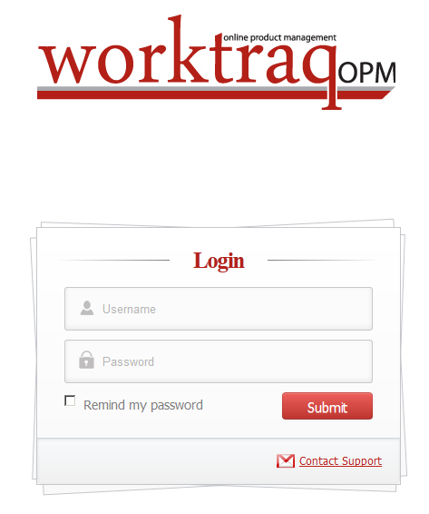  
**Step 2:** Please enter the your username or password to login the worktraq system. If the your username or password is not correct, the system will appear alert. If you forget your account, please contact … . We sent your account via email, phone…

# System – Admin

## **Home**

When you login successful, you will see homepage for system – admin, this page will statistics all total: order, shippping and show statistics form chart.  
(This page is layout system website: )

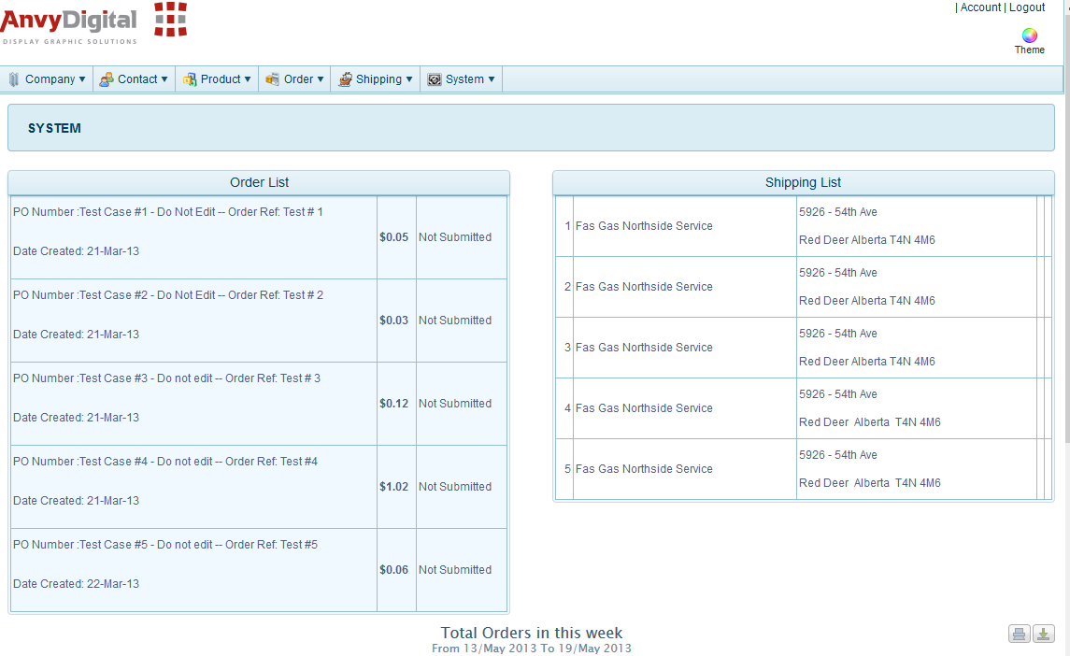

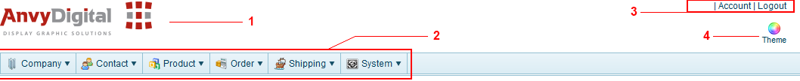

* **1** – Company logo
* **2** – Menu system have all:
  + Company
    - Company
    - Location
    - Region
    - Role
    - Function for company
  + Contact
    - Contact
    - User
  + Product
    - Tags
    - Material
    - Products
    - Products Group
    - Packages
    - Threshold Group
    - Signage Layout
  + Order
    - Order
  + Shipping
    - Shipping
    - Tracking Company
  + System
    - Province
    - Support
    - Settings
    - Message
    - Email Templates
    - Global Configuration
    - Module

(If you want know information: you can click menu corresponding)

* **3** – Account | Logout:
  + Account information 
  + here you can log out, you can click 
* **4** - 
  + You can choose many layout color for this site admin – when you click you will see all them (Only you choose 1 them). Change for all browser then you click checkbox Apply for all browse.

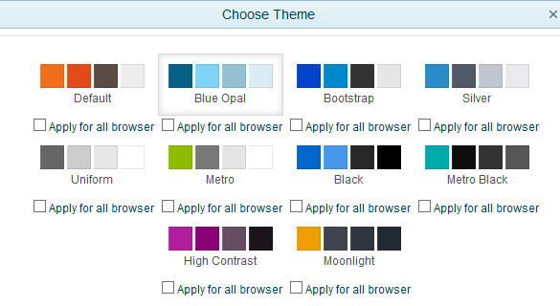

In Homepage system admin you have table Order List: Will show all Order list for customer ordered on webiste.

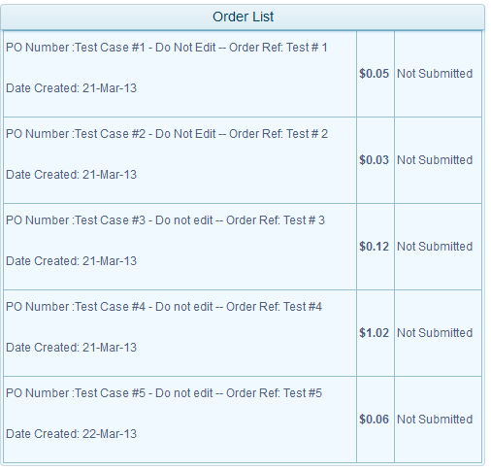

Table Shipping List: Will show all shipping list in day.

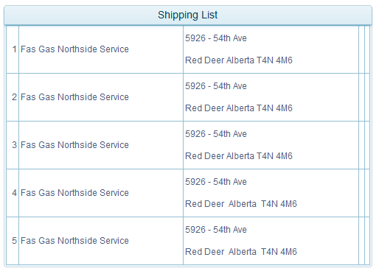

This Chart for Total orders in this week

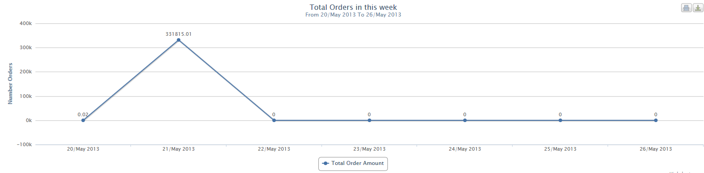

You can export to raster or vector images, please click   
Or you can print this chart, you can click 

## **company – company**

Description: You will know Company information in this menu to help you know lates.

You can click from menu top: Company 🡪 Company, or from menu left(when you clicked at least 1 menu from menu top) and then click menu you want, here Company:

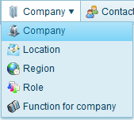 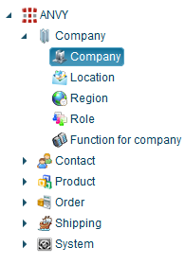

Pages Company:

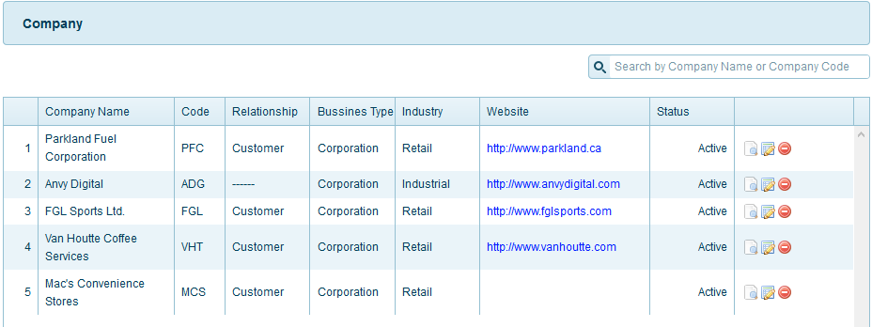

Function menu top right for page:

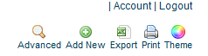

### Advanced

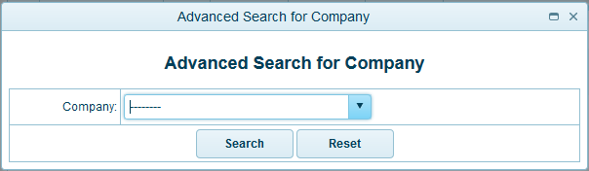

All company registed, you can see and then you need select 1 company you want search:

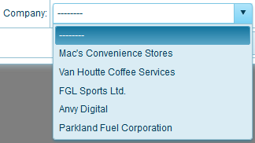

And then click button search: 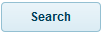 or reset fileds selected by you 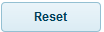

### Add New

Please click the link **Company** from menu **Company**

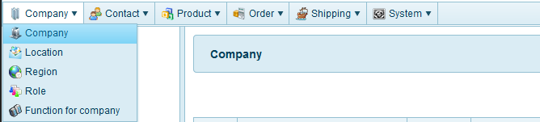You can saw this page **Company**

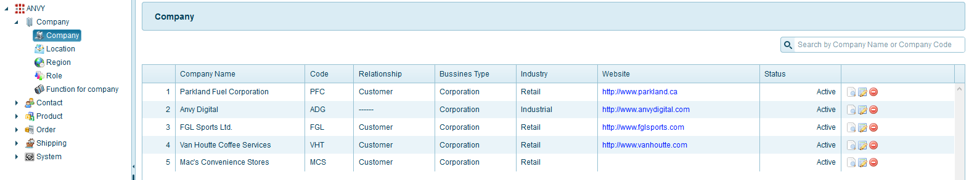

Please click the link **Add New** – menu top right from page **Company**

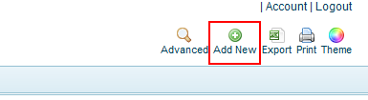

You can see table information you need input:

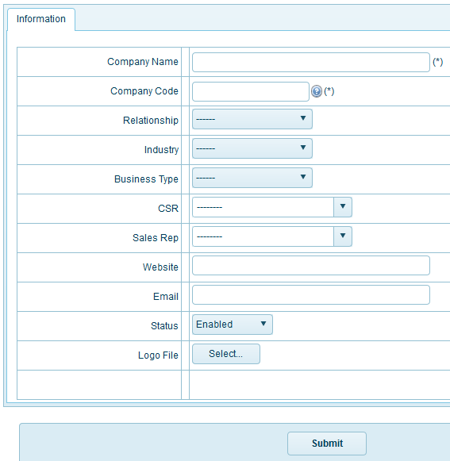

* **In field RelationShip**: if you have relationship for customer (you can choose Customer) or you have relationship for vender (you can choose vendor) or you have both relationship for customer and vendor (you can choose Both)  
  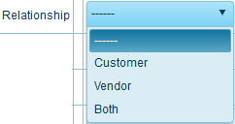
* **In field Industry:** filed for company  
  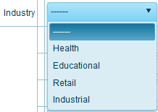
* **In field Business type:** filed Business type for company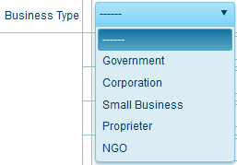
* **In field CSR:**   
  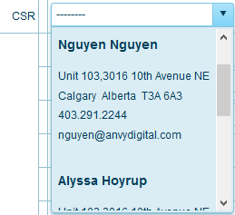
* **In field Sales Rep:** All information Sales rep as (name, address, phone, email)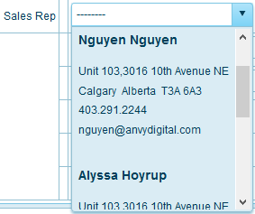
* **Status for company** Enabled or Disabled:   
  (You can action **select from dropdown – default Enabled**)
  + Enabled: Status for company active
  + Disabled: Status for company inactive

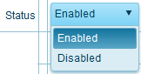

After you input all field finish and then click button: .

### Export

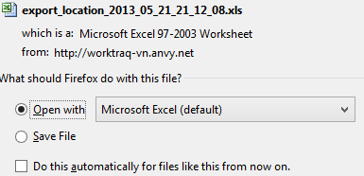

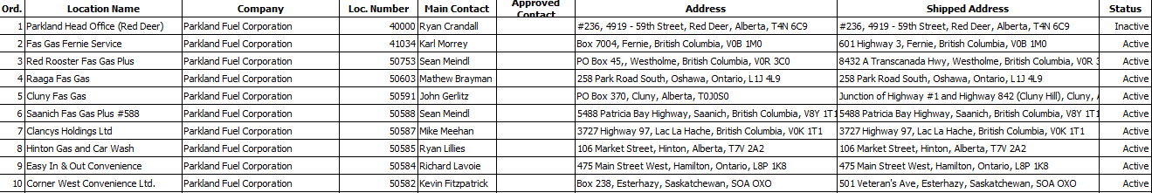

You want file contact Excel, please click icon Export

### Print

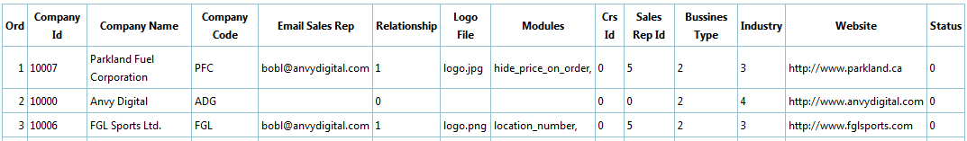

You want print file contact, please click icon print

### Content - page

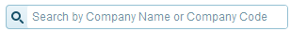

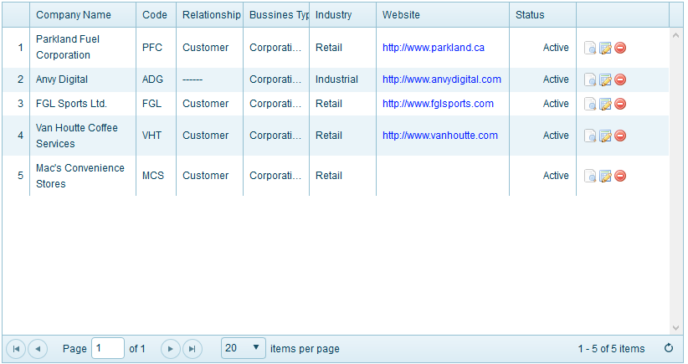

**Search company:**You can search company use field name, input company name you want to search here**.**







**Icon _view click ** View all information for company

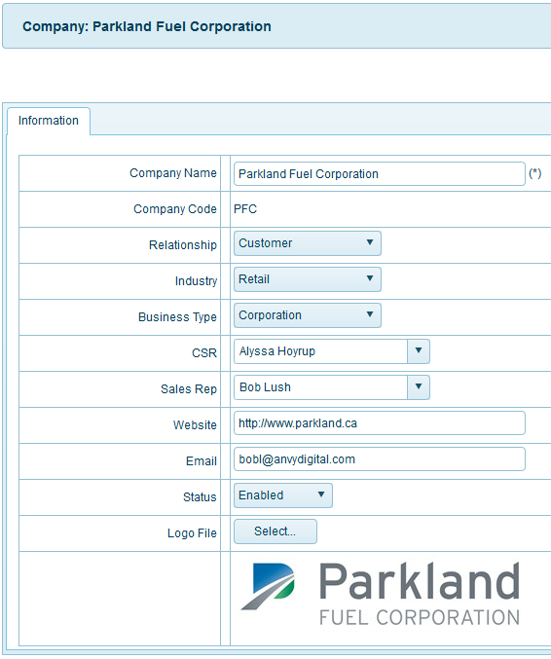

**Icon _edit click: ** if you want Edit information company, please click icon_edit and then   
click ok, you will edit company selected.

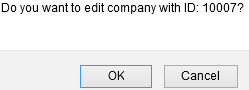

All field similar page Add new (you can view lates **Add New**)

**Icon _ delete: ** to delete company selected, please click ok to delete company

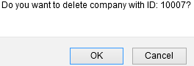

## **company – location**

Description: All location for company registed

You can click from menu top Company 🡪 Location, or from menu left(when you clicked at least 1 menu from menu top) and then click menu you want, here Location:

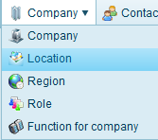 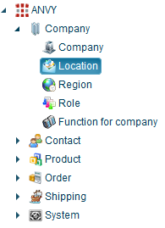

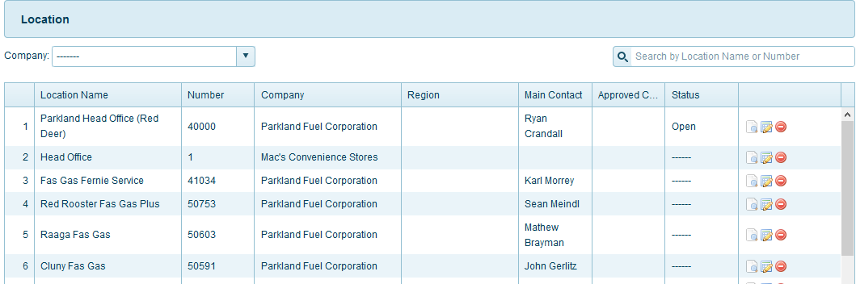

Function menu top right for page:

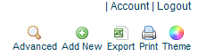

### Advanced

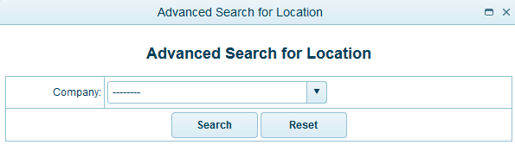

All company registed, you can see and then you need select 1 company you want search:

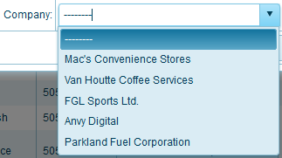

And then click button search:  or reset fileds selected by you 

### Add New

Please click the link **location** from menu **Company**

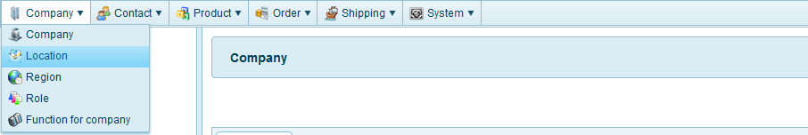

You can saw this page **location**

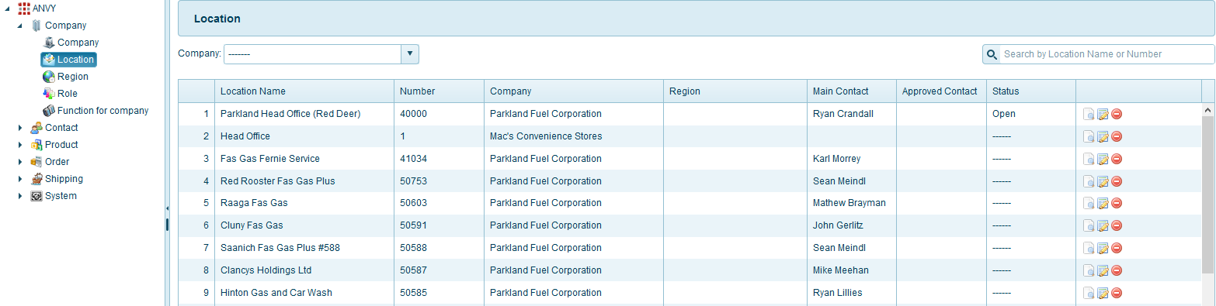

Please click the link **Add New** – menu top right from page **Location**



You can see 3 table you need input:

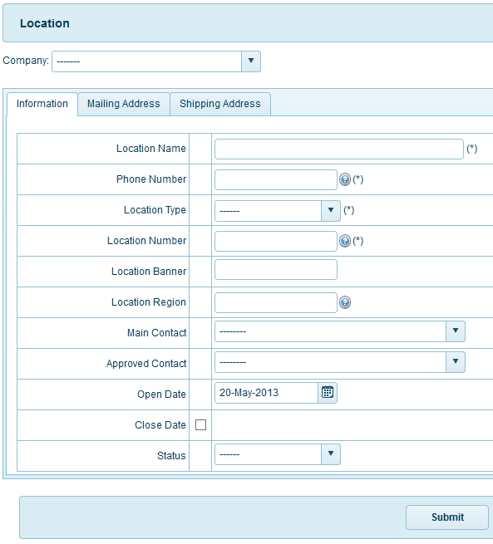

First you can choose company from field this, here you can see all company registed:

* **Company** – Select Company form list: (this field **required**)  
  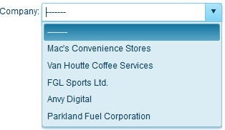

You can see tab information you need input:

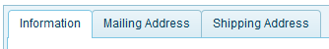

* **Field Phone Number:** phone number for location company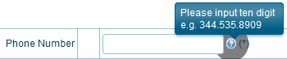
* **Location type for company**: type location for company  
  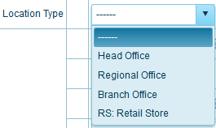
* **Maincontact** (**reuiqred choose company first**): When you choose company, you will see all  
  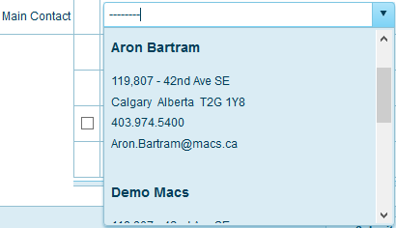
* **Approved Contact**: if you contact to Maincontact no reply or Maincontact busy, you can contact to approved contact.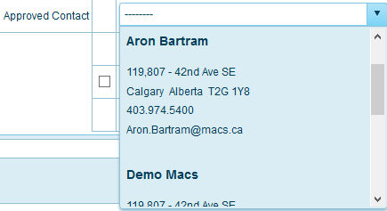
* **Status** for location Closed or Planned: (You can action **select from**)
  + Closed: Status for location will closed, mean not active
  + Planned: Status for location will active and planed waitting

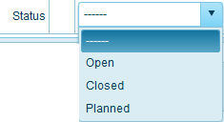

You can see tab Mailing address you need input:

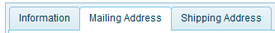

* You choose Address Province and Country for location company you want add new location  
  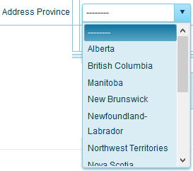 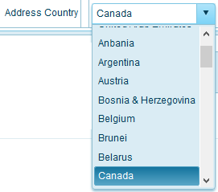

You can see tab Mailing address you need input:

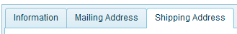

* You can see tab Shipping Address you need check or not check (**default check**):
  + Check : will use default address in loaction for company
  + Not Check: no use default address, will use address for company registed default



After you input all field finish and then click button: 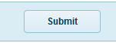  
Export 

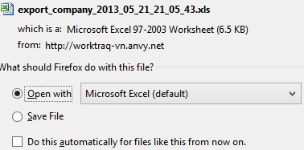



You want file contact Excel, please click icon Export

### Print

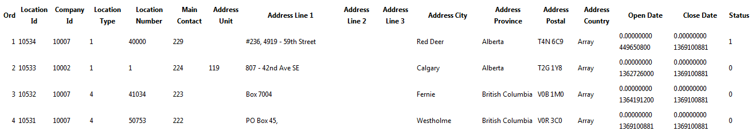

You want print file contact, please click icon print

### Content - page

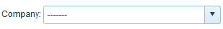 

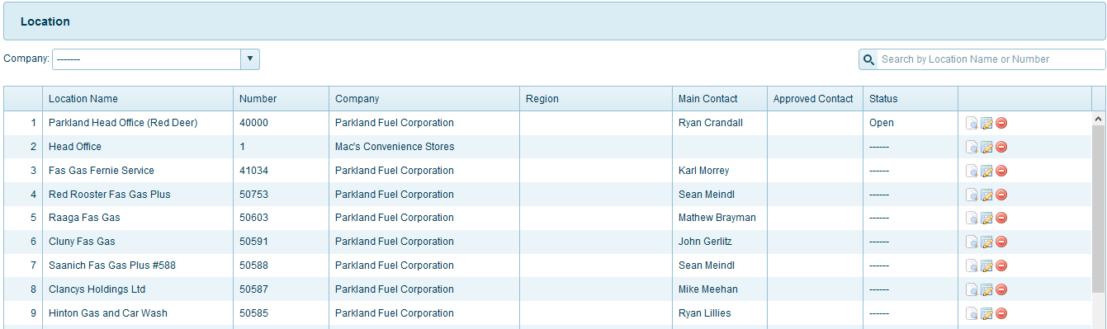

**Search location:**  
You can search location use field name or field company or both. Input location name or choose company or both you want to search here

 





**Icon _view click ** View location information

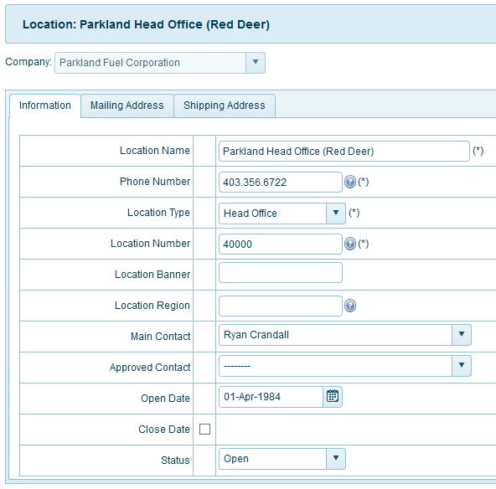

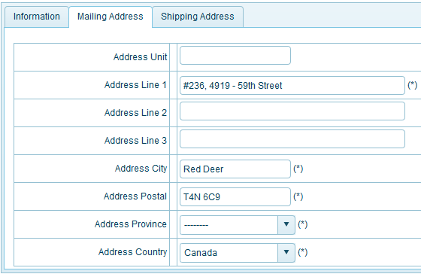

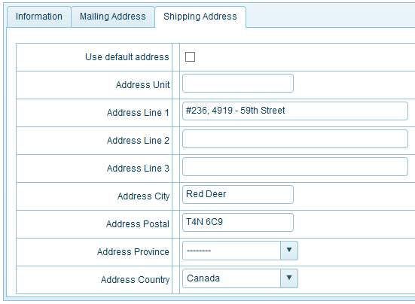

**Icon _edit click: ** if you want Edit location company, please click icon_edit and then   
click ok, you will edit location company selected.

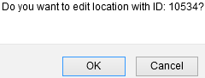

Here, you can not Edit Company name

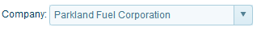

All field similar page Add new (you can view lates **Add New**)

**Icon _ delete: ** to delete location selected, please click ok to delete location

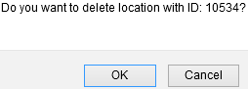

## **company – Region**

Description: Region for company

You can click from menu top Company 🡪 Region, or from menu left(when you clicked at least 1 menu from menu top) and then click menu you want, here Region:

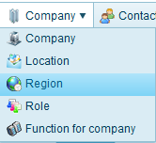 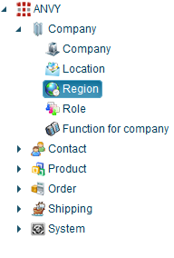

Function menu top right for page:

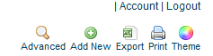

### Advanced

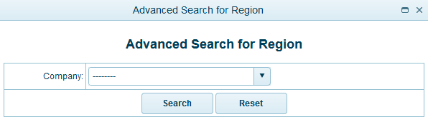

All company registed, you can see and then you need select 1 company you want search:

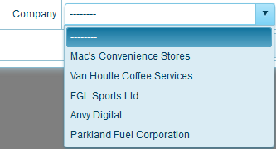

And then click button search:  or reset fileds selected by you 

### Add New

Please click the link **Region** from menu **Company**

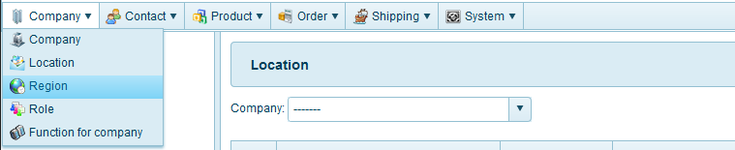

You can saw this page **region**

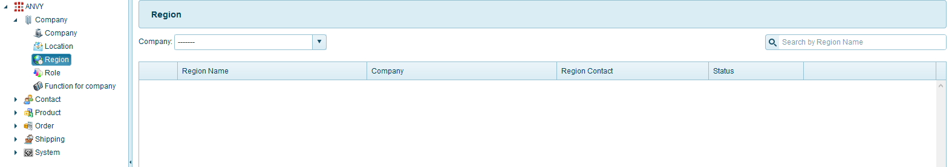

Please click the link **Add New** – menu top right from page **Region**



You can see tab information you need input:

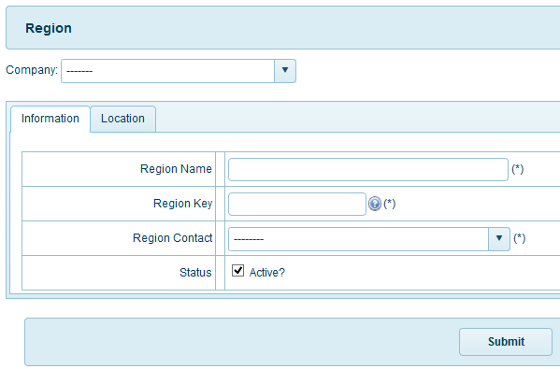

First you can choose company from field this, here you can see all company registed:

* **Company** – Select Company form list: (this field **required**)  
  

Tab information you need input:

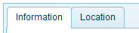

* **Region contact**: All contact region for company registed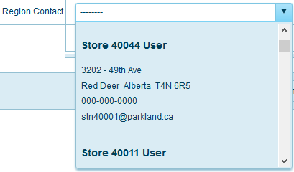
* **Status for Region** Active or Not Active:   
  (You can action **select from dropdown – default Active**)
  + Active: Status for region active, mean add new Region successfully
  + Not Active: Status for region inactive  
    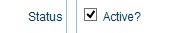

Tab location you need select location for company registed:

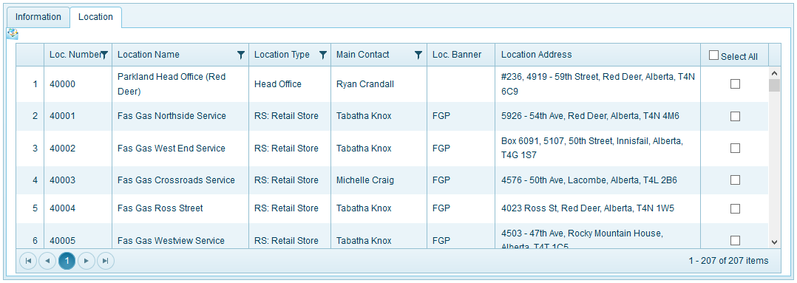

When you click icon  on field you will see **filter lates**:



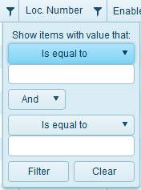 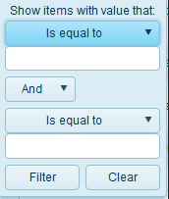 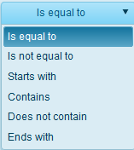 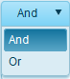

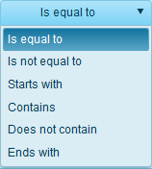

After you input, check all field finish. You can click button:  to finish add new Region.

## **company – Role**

Description: Role of company

You can click from menu top Company 🡪 Role, or from menu left(when you clicked at least 1 menu from menu top) and then click menu you want, here Role:

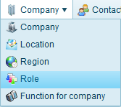 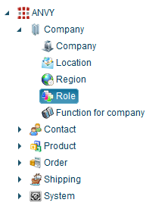

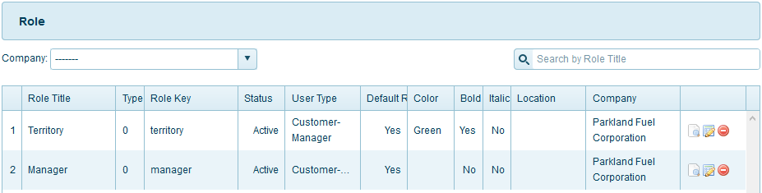

Function menu top right for page:



### Advanced

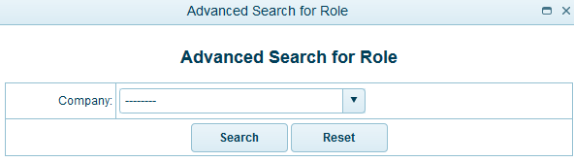

All company registed, you can see and then you need select 1 company you want search:



And then click button search:  or reset fileds selected by you 

### Add New

Please click the link **role** from menu **Company**

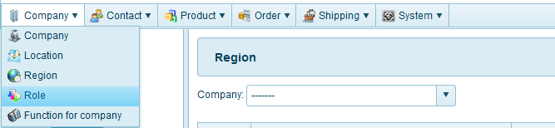

You can saw this page **role**

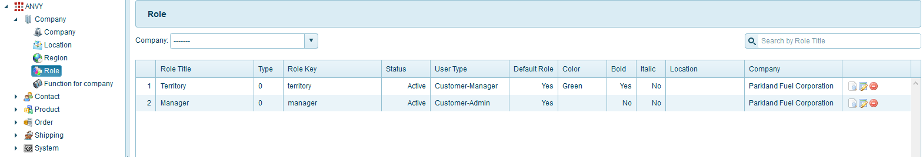

Please click the link **Add New** – menu top right from page **Role**



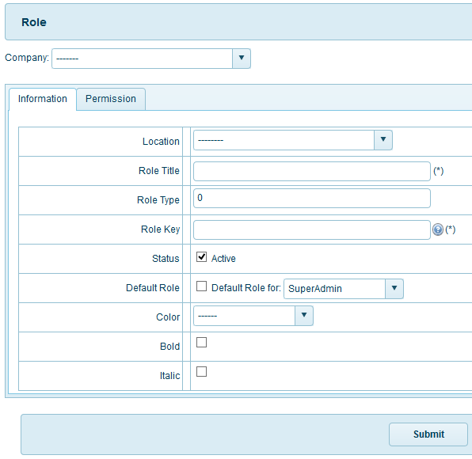

First you can choose company from field this, here you can see all company registed:

* **Company** – Select Company form list: (this field **required**)  
  

You can see 2 table you need input (information, permision):

In tab Information:

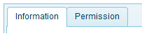

**Location**: All location of company you selected

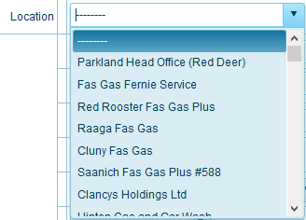

**Default Role**: Default set some permisson for other user  
example: if you set default SuperAdmin for Parkland company will have some permission(set all users for this group) and then user for Super admin will add new some permission private.

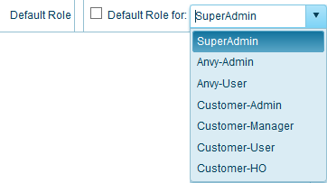

**Color for Role text**

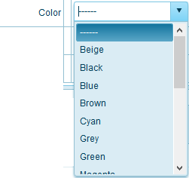

In tab Permission:

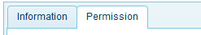

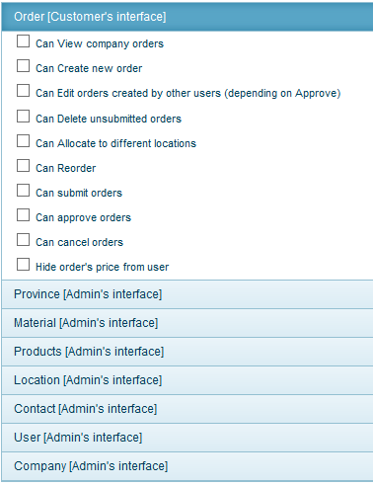

* **View**: view all order from all company’s location. If don’t check default view their own location’s order
* **Create**: create new orders
* **Edit**: edit all company order(depend on rule view). If don’t have, default can edit their own orders
* **Delete**: delete not submitted orders (depending on rule view), default can delete their own order
* **Allocate**: allocate order item to different allocations(depeding on rule view and product’s allocations and user’s allocation). Default can allocate to their own allocation
* **Reorder**: reoder submitted orders
* **Submitted**: submitted orders. If don’t have default change status of not-submitted order to “pending”
* **Approved**: approved pending orders
* **Cancel**: can cancel pending orders
* **Hide price**: hide price from users’s

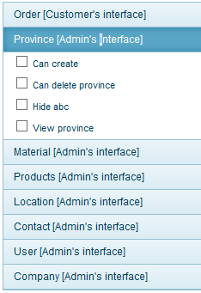

From this function will only for customer-admin. Default check all view for customer-admin

* **Create**: when log-in to admin page can create new province
* **Delete**: when log-in to admin page can delete province
* **Create**: when log-in to admin page can hide province
* **View**: when log-in to admin page can view province

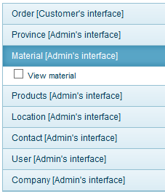

**View** : can view menu material

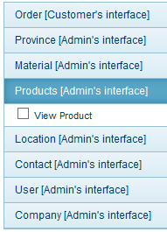

**View** : can view menu product

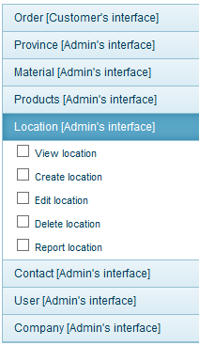

* **View** : when log in to admin page can view menu location
* **Create**: when log in to admin page can create new location
* **Edit**: when log in to admin page can edit location
* **Delete** : when log in to admin page can delete location
* **Report** : when log in to admin page can report ifllocation right or wrong

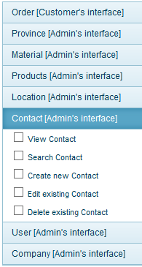

* **View**: can view contact list
* **Search**: can search for contact
* **Create**: can create new contact
* **Edit**: can edit contact
* **Delete**: can delete contact

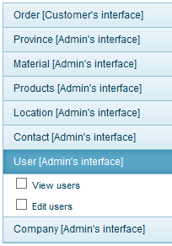

* **View**: can view users list
* **Edit**: can edit users

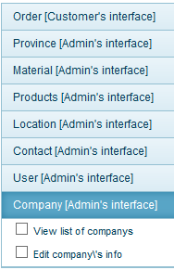

* **View**: view company list
* **Edit**: can edit company information

After you input all field finish and then click button: .

### Export

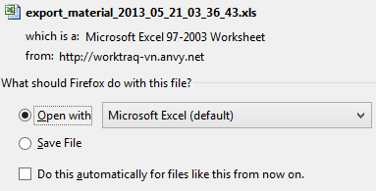

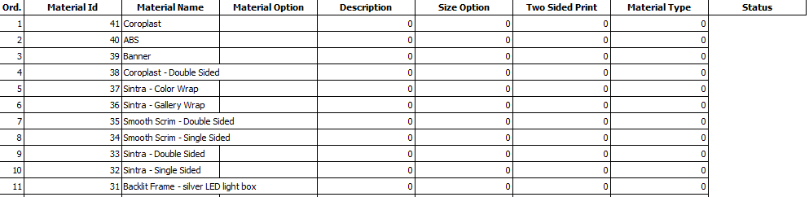

You want file contact Excel, please click icon Export

### Print



You want print file contact, please click icon print

### Content - page

 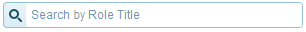

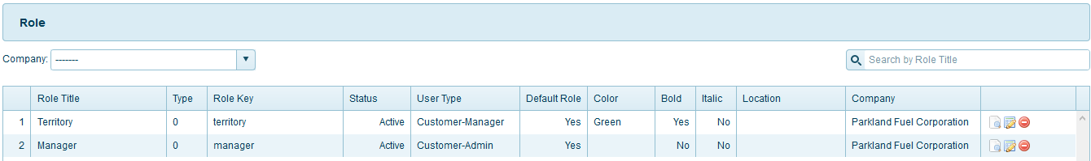

**Search Role:**  
You can search role use field name or field company or both. Input role name or choose company or both you want to search here

 





**Icon _view click ** View role information

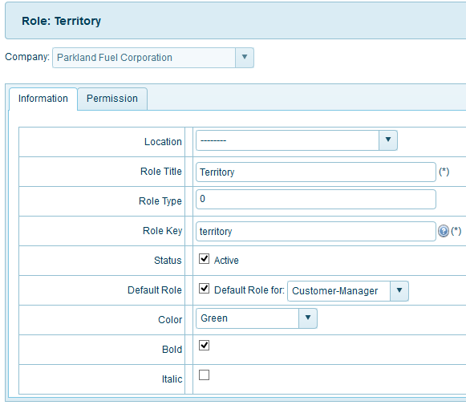

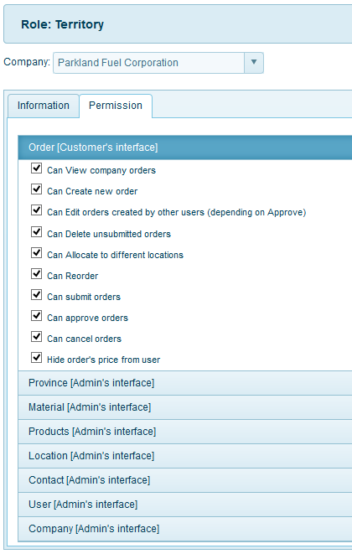

**Icon _edit click: ** if you want Edit role, please click icon_edit and then click ok, you will edit role selected.

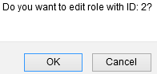

Here, you can not Edit Company name



All field similar page Add new (you can view lates **Add New**)

**Icon_ delete: ** to delete location selected, please click ok to delete role

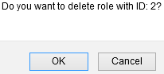

## **contact – contact**

Description: User’s contact

You can click from menu top Contact 🡪 Contact, or from menu left(when you clicked at least 1 menu from menu top) and then click menu you want, here Contact:

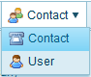 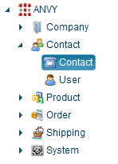

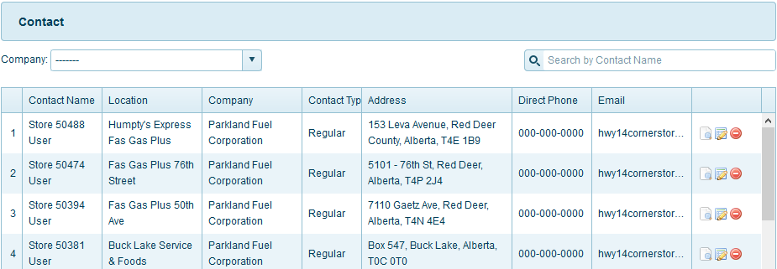

Function menu top right for page:



### Advanced

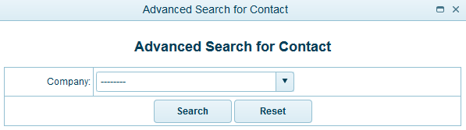

All company registed, you can see and then you need select 1 company you want search:



And then click button search:  or reset fileds selected by you 

### Add New

Please click the link **Contact** from menu **Contact**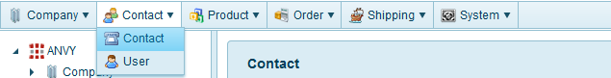

You can saw this page **Contact**

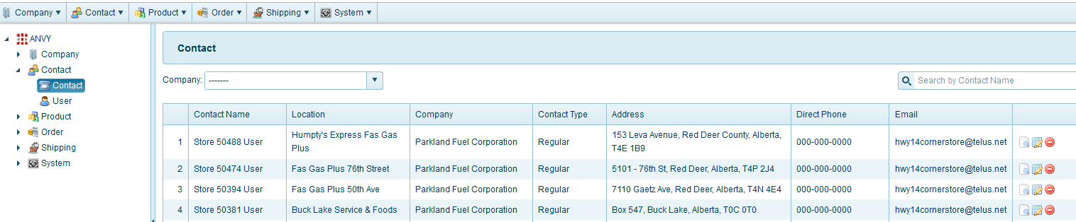

Please click the link **Add New** – menu top right from page **Contact**



First you can choose company from field this, here you can see all company registed:

* **Company** – Select Company form list: (this field **required**)  
  

In **Tab Information:**

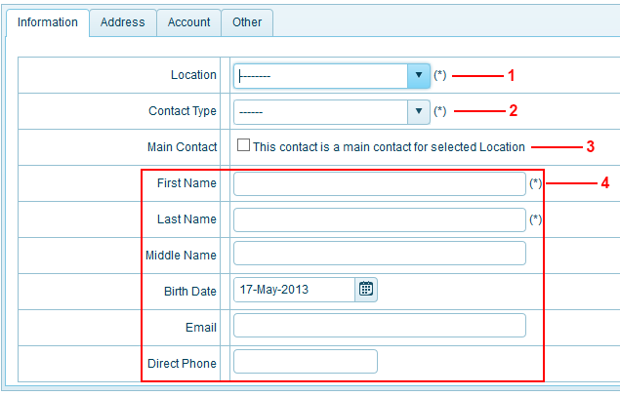

* **1** – After select company you will saw all location for this **company** you choose
* **2** – Contact type: all type user for website, here you have 3 options  
    
  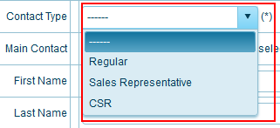
* **3** – This contact is a main contact for selected Location
* **4** – Information for user  
  (First name, Last name, Middle name, Birth date, E-mail, Direct phone) you can input

In **Tab Address:**

You choose address – this field (**required**) , here you have 3 options

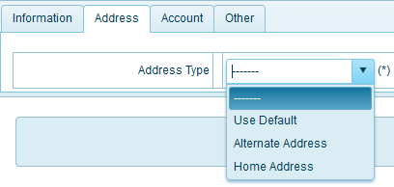

* **Use Default**: use address for company registry
* **Alternate Address**: When you choose this option you will input many options for address replacement  
  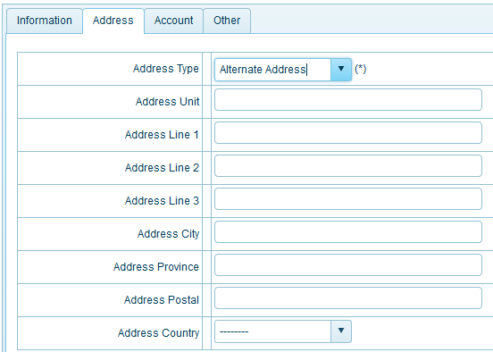
* **Home Address**: Similar Alermate Address but you use address home for you or address another people you know.

In **Tab** **Account:**

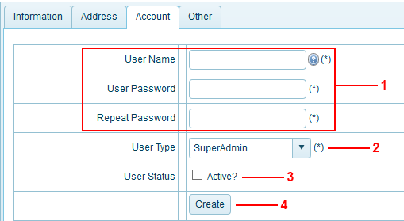

* **1** – This field information user to login website: <http://worktraq.anvy.net>
* **2** – User type: all type user for website, here you have many options:  
    
  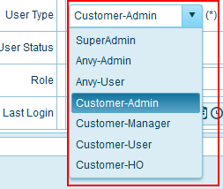  
  + **Super Admin:** permission full system
  + **Anvy-Admin:** full control but some permission for system not allowed
  + **Anvy – user:** permission depending user type Anvy-Admin
  + **Customer-admin:** have can edit layout template admin for mine company and insert some permission as: insert company user, dispached order, insert location – contact – company products….
  + **Customer-manager:** have permissionCustomer-Admin but not have important permission as: insert user, insert location - contact
  + **Customer-user:** This user type default customer-HO have rule : “view,edit...”
  + **Customer-HO:** No permission as customer
* **3** – Status for user Active or Not Active (You can action **checkbox – default Active**),you have 2 options:  
    
  
  + Active: Status when you created will active similar account actived and can use
  + Not Active: as you do not create account means account not use.
* **4** – Create user (but user finish tab information, address)

In **Tab Other:**

Input fields for information for you (Mobile phone, Fax number, Home phone)

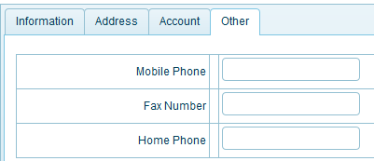

**Step 3:** Then you finish **Step 2** you can click button **Submit** finish create account

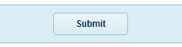

### Export





You want file contact Excel, please click icon Export

### Print

You want print file contact, please click icon print

### Content - page

 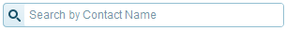

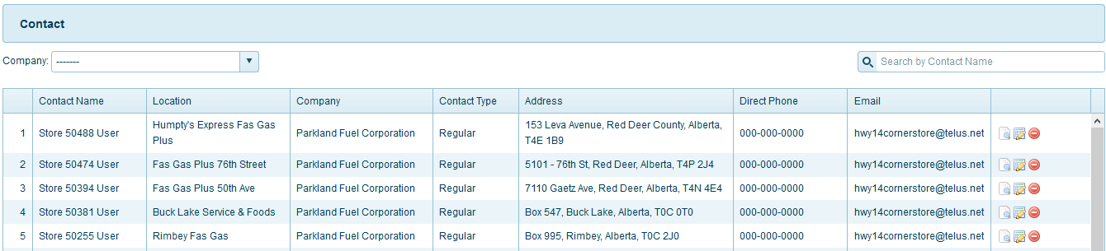

**Search contact:**  
You can search contact use field name or field company or both. Input contact name or choose company or both you want to search here

 





**Icon _view click ** View contact information

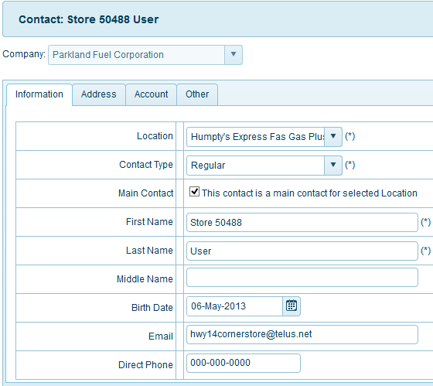

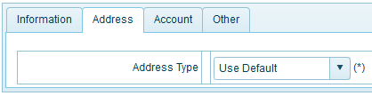

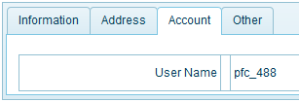

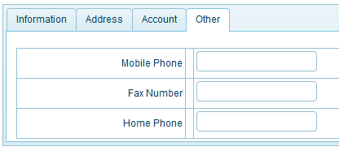

**Icon _edit click: ** if you want Edit Contact, please click icon_edit and then click ok, you will edit contact selected.

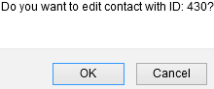

Here, you can not Edit Company name



All field similar page Add new (you can view lates **Add New**)

**Icon _ delete: ** to delete contact selected, please click ok to delete contact

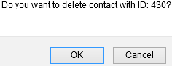

## **contact – User**

Description: If you have user account you can go to the address website : <http://worktraq.anvy.net> and login with account you have.

Create user for website, you need:

* You have or you know name company for mine
* And then you need create contact first(you can see lates **CREATE CONTACT**) to use contact name when create user account from tab information because this field **required**  
  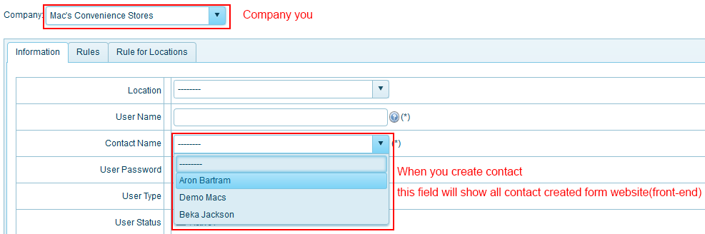
* When you create contact finish you continue creat user account   
  (CREATE USER ACCOUNT)

This website have 7 user type to login:



* **Super Admin:** permission full system
* **Anvy-Admin:** full control but some permission for system not allowed
* **Anvy – user:** permission depending user type Anvy-Admin
* **Customer-admin:** have can edit layout template admin for mine company and insert some permission as: insert company user, dispached order, insert location – contact – company products….
* **Customer-manager:** have permissionCustomer-Admin but not have important permission as: insert user, insert location - contact
* **Customer-user:** This user type default customer-HO have rule : “view,edit...”
* **Customer-HO:** No permission as customer

Ok, You have account. If website error you can know who last login, this field Last login on Create User

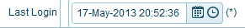

You can click from menu top Contact 🡪 User, or from menu left (when you clicked at least 1 menu from menu top) and then click menu you want, here User:

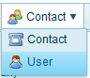 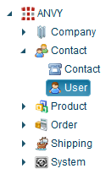

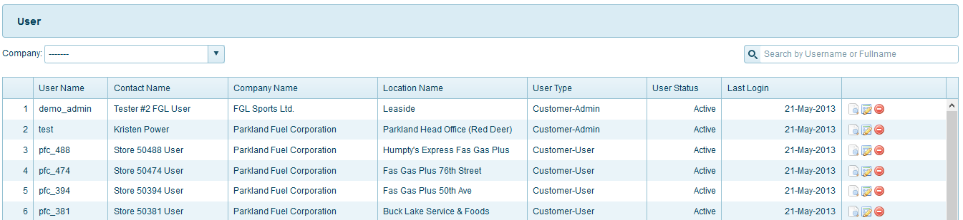

Function menu top right for page:



### Advanced

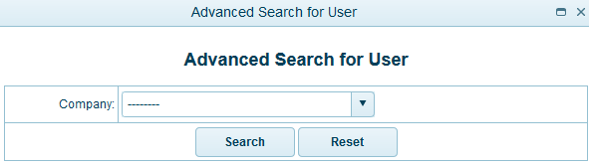

All company registed, you can see and then you need select 1 company you want search:



And then click button search:  or reset fileds selected by you 

### Add New

Please click the link **User** from menu **Contact**

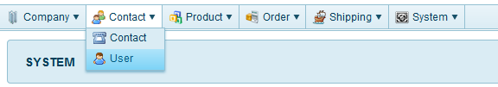

You can saw this page **User**

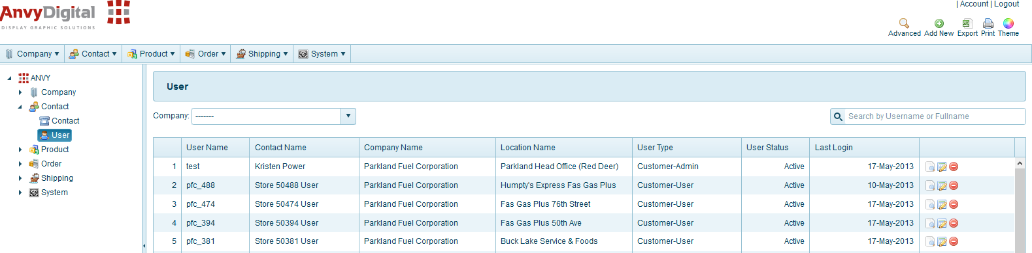

Please click the link **Add New** – menu top right from page **User**



Here you can create user account:

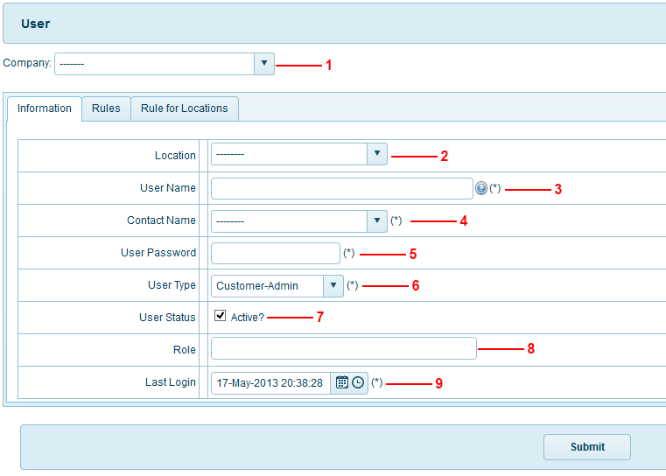

First you can choose company from field this, here you can see all company registed:

* **1** – Select Company form list: (this field **required**)  
  
* **2** – After select company you will saw all location for this company you choose(1)  
  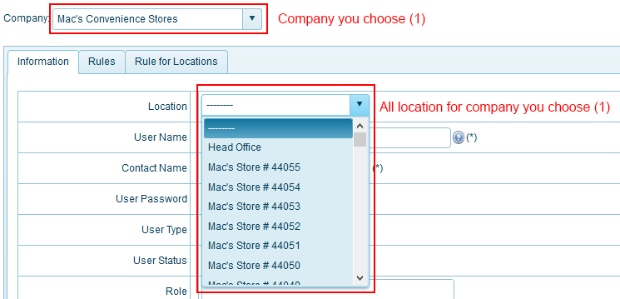
* **3** – Input user name (user name when you login website: <http://worktraq.anvy.net>)  
    
  
* **4** – Contact name: You created contact(CREATE CONTACT) and you choose company   
  (**1 - Required**) you can saw all contact name:  
    
  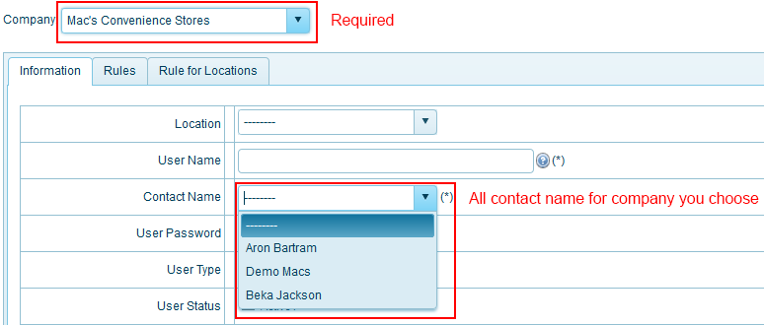
* **5** – User password for user name(**3**) when you login website: <http://worktraq.anvy.net>  
    
  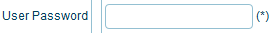
* **6** – User type: all type user for website, here you have many options type:  
    
    
  + **Super Admin:** permission full system
  + **Anvy-Admin:** full control but some permission for system not allowed
  + **Anvy – user:** permission depending user type Anvy-Admin
  + **Customer-admin:** have can edit layout template admin for mine company and insert some permission as: insert company user, dispached order, insert location – contact – company products….
  + **Customer-manager:** have permissionCustomer-Admin but not have important permission as: insert user, insert location - contact
  + **Customer-user:** This user type default customer-HO have rule : “view,edit...”
  + **Customer-HO:** No permission as customer
* **7** – Status for user Active or Not Active (You can action **checkbox – default Active**)  
    
    
  + Active: Status when you created will active similar account actived and can use
  + Not Active: as you do not create account means account not use.
* **8** – Role: for company user can Not input this field  
    
  but you want input this field you can:
  + When you choose company field (**1**), because this company for you have role created from before, you can see:  
    Click link Role from menu Company  
    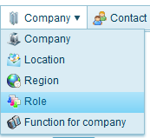  
    And then you can see Tittle Role for company  
      
    Here you have 2 Role for company Parkland Fuel Corporation:
    - Territory
    - Manager

Role: use as permission for user, you can see exmaple Role – Territory  
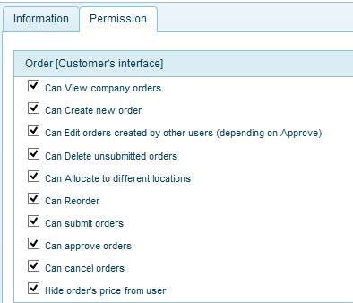  
You can know lates all role, please click link ROLE

* + Ok, when company for you have role you can see Role for company in options on Role, you can choose 1 or more Role depending on the purpose  
    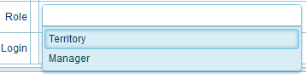
* **9** – Last login : default get time user creat account (This field userful if website error you can know who last login or edit…)  
    
  
* **(*)** this field required

**Step 3:** Then you finish **Step 2** you can click button **Submit** finish create account



### Export





You want file contact Excel, please click icon Export

### Print

You want print file contact, please click icon print

### Content - page

 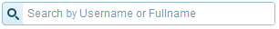

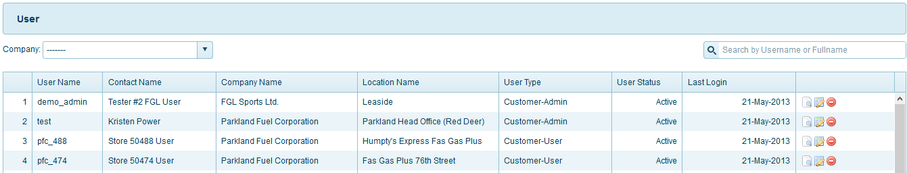

**Search user:**  
You can search user use field name or field company or both. Input user name or choose company or both you want to search here

 





**Icon _view click ** View user information

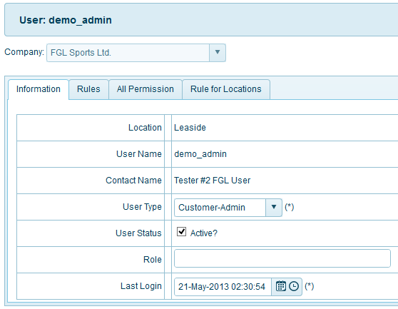

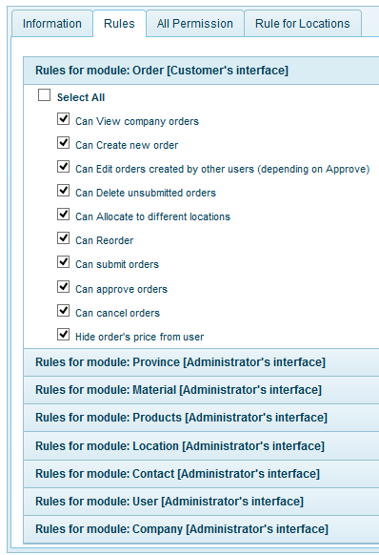

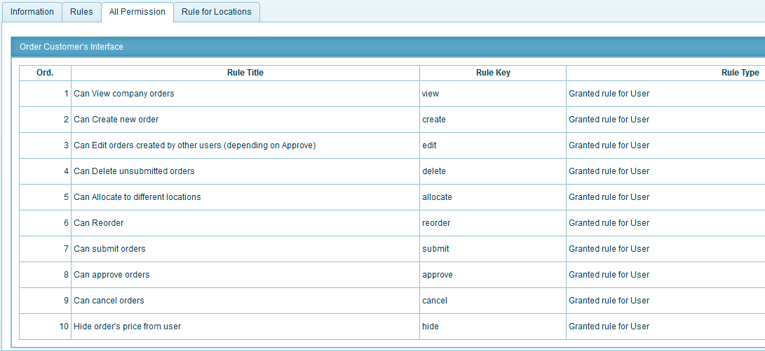

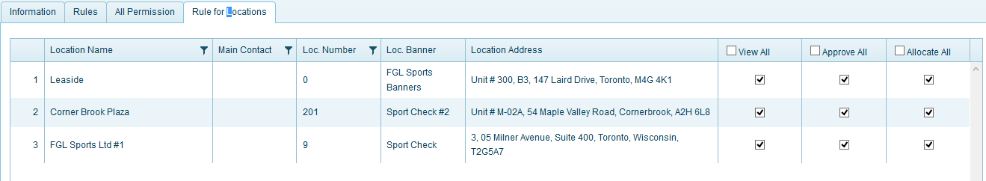

**Icon _edit click: ** if you want Edit User, please click icon_edit and then click ok, you will edit User selected.

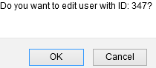

Here, you can not Edit Company name



All field similar page Add new (you can view lates **Add New**)

**Icon_ delete: ** to delete user selected, please click ok to user contact

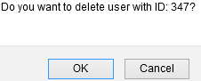

## **products – tags**

Description: Product’s catalogue.

You can click from menu top Product 🡪 Tags, or from menu left (when you clicked at least 1 menu from menu top) and then click menu you want, here Tags:

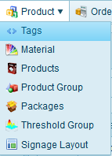 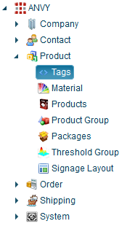

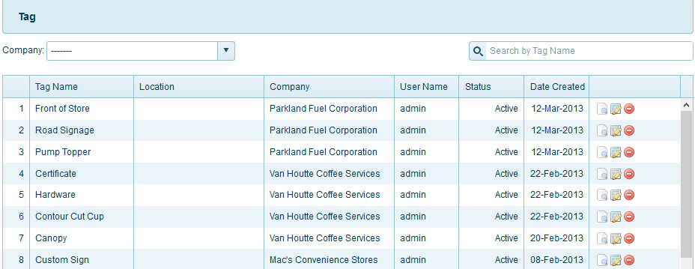

Function menu top right for page:



### Advanced

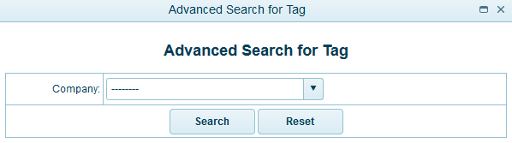

All company registed, you can see and then you need select 1 company you want search:



And then click button search:  or reset fileds selected by you 

### Add New

Please click the link **Tags** from menu **Product**

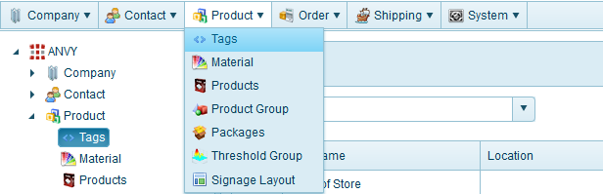

You can saw this page **Tags**

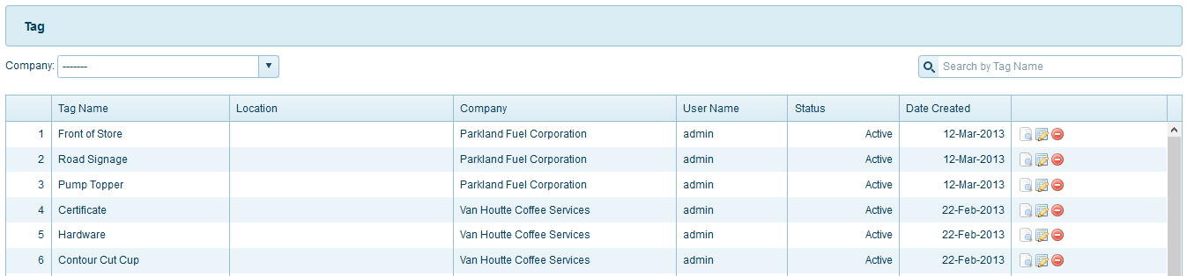

Please click the link **Add New** – menu top right from page **Tags**



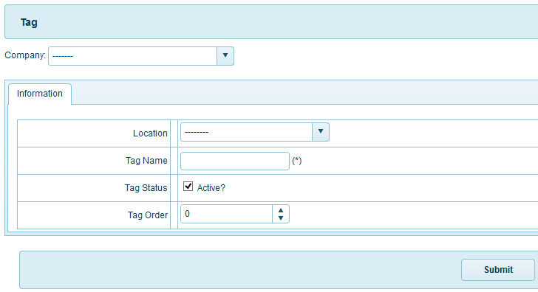

First you can choose company from field this, here you can see all company registed:

* **Company** – Select Company form list: (this field **required**)  
  
* **Location** – All location for company you choose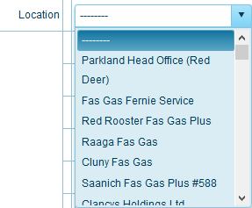
* Status for tag Active or Not Active (You can action **checkbox – default Active**)  
    
    
  + Active: Status when you created will active similar tags actived and can use
  + Not Active: as you do not create tags means tags not use.

After you input, check all field finish. You can click button:  to finish add new tags.

### Export





You want file contact Excel, please click icon Export

### Print

You want print file contact, please click icon print

### Content - page

 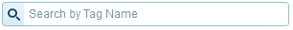

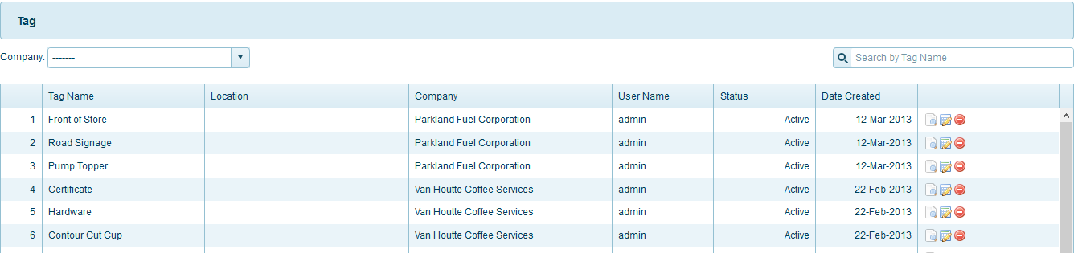

**Search tags:**  
You can search tags use field name or field company or both. Input tags name or choose company or both you want to search here

 





**Icon_view click ** View tags information

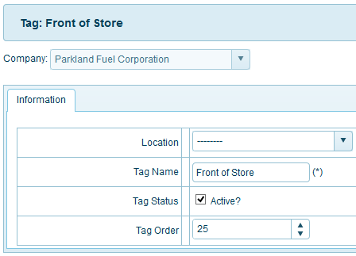

**Icon_edit click: ** if you want Edit products tags, please click icon_edit and then click ok, you will edit products tags selected.

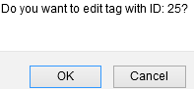

Here, you can not Edit Company name



All field similar page Add new (you can view lates **Add New**)

**Icon_ delete: ** to delete products tags selected, please click ok to delete products tags

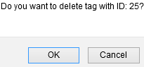

## **products – material**

Description: Products material

You can click from menu top Product 🡪 Material, or from menu left(when you clicked at least 1 menu from menu top) and then click menu you want, here Material:

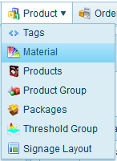 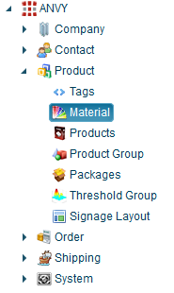

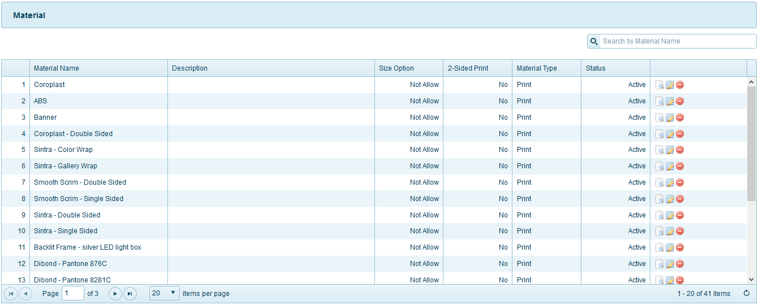

Function menu top right for page:



### Advanced

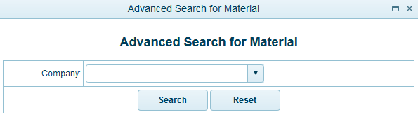

All company registed, you can see and then you need select 1 company you want search:



And then click button search:  or reset fileds selected by you 

### Add New

Please click the link **Material** from menu **Product  
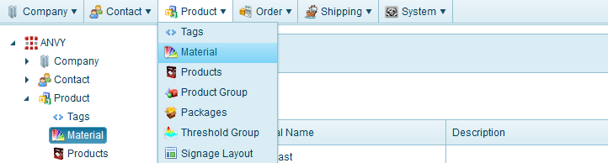**

You can saw this page **Material**

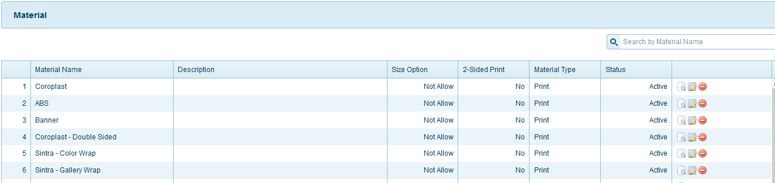

Please click the link **Add New** – menu top right from page **Material**



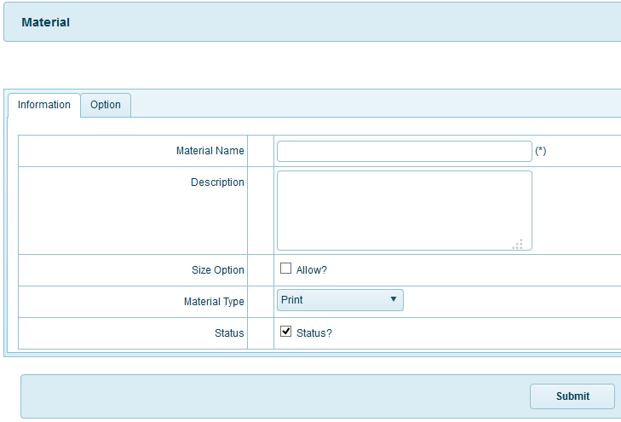

* **Size Option**: allow or not
* **Material Type**: Print
* **Status for Material** Active or Not Active (You can action **checkbox – default Active**)  
    
    
  + Active: Status when you created will active similar Material actived and   
    can use
  + Not Active: as you do not create Material means Material not use.

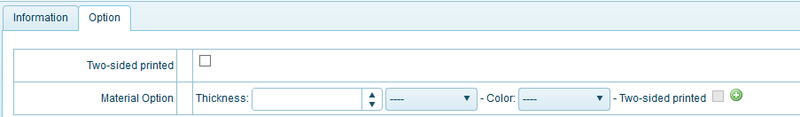

* Thickness material and color material  
  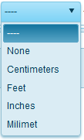 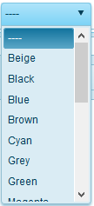  
    
  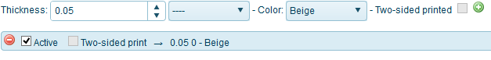  
  When you choose thickness and color for material you can click icon 

After you input, check all field finish. You can click button:  to finish add new material.

### Export





You want file contact Excel, please click icon Export

### Print

You want print file contact, please click icon print

### Content - page

 

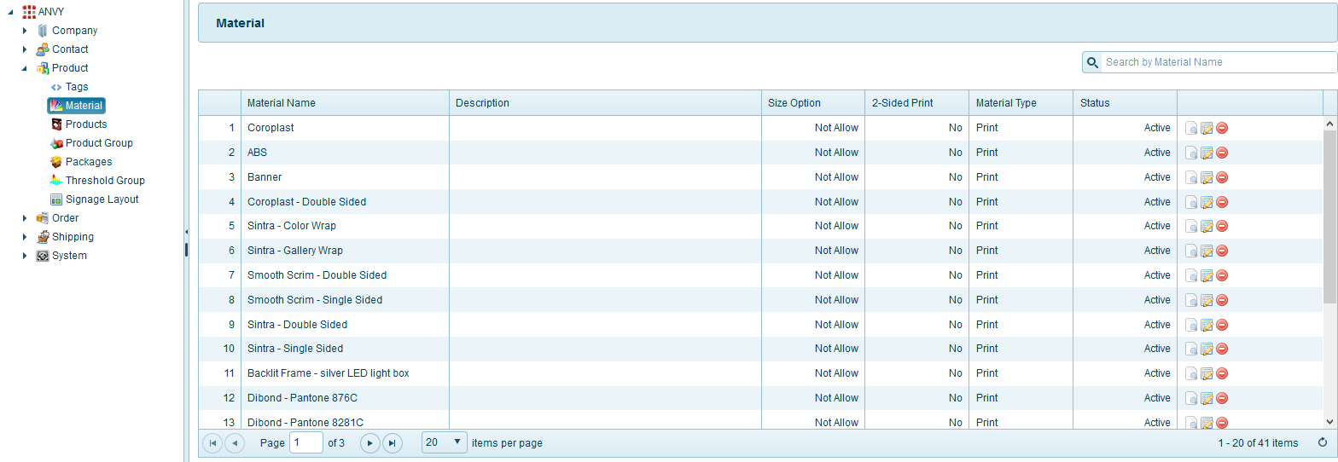

**Search material:**  
You can search material use field name or field company or both. Input material name or choose company or both you want to search here



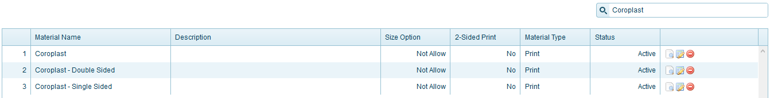



**Icon_view click ** View material information

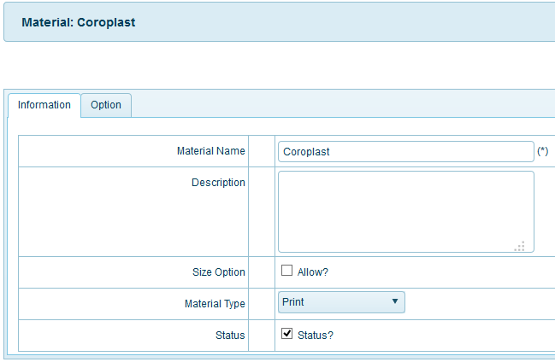

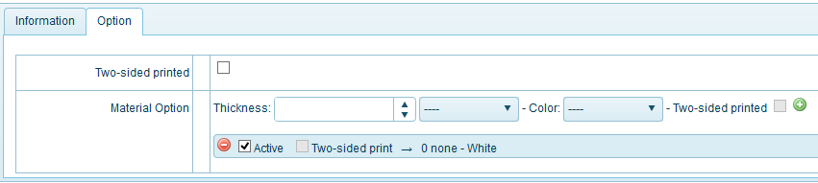

**Icon_edit click: ** if you want Edit products material, please click icon_edit and then click ok, you will edit products material selected.

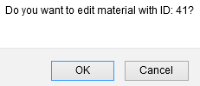

All field similar page Add new (you can view lates **Add New**)

**Icon_ delete: ** to delete products material selected, please click ok to delete products material

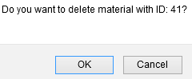

## **products – Products**

Description: List all products information

You can click from menu top Product 🡪 Products, or from menu left(when you clicked at least 1 menu from menu top) and then click menu you want, here Products:

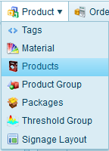 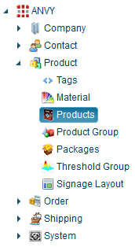

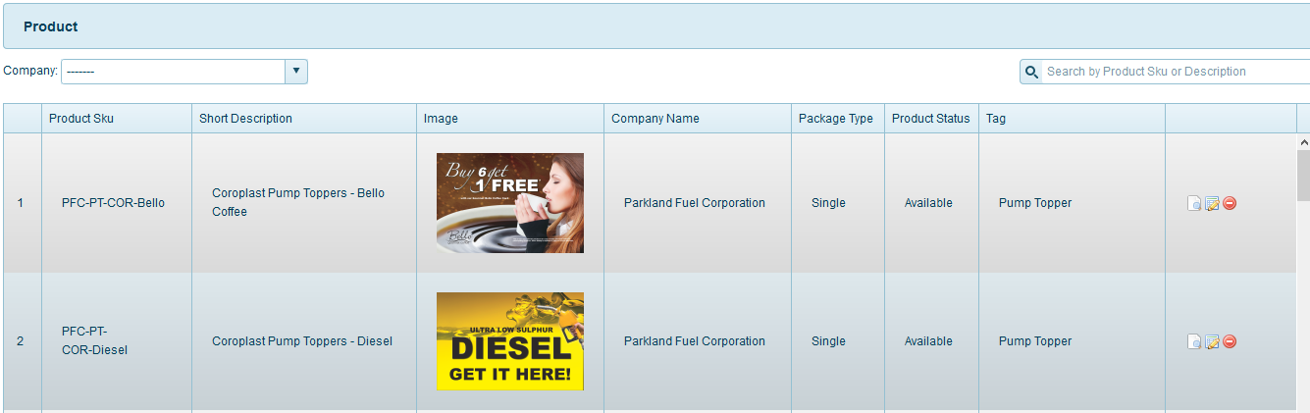

Function menu top right for page:



### Advanced

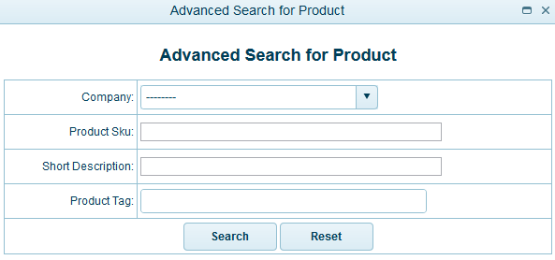

All company registed, you can see and then you need select 1 company you want search:



And then click button search:  or reset fileds selected by you 

### Add New

Please click the link **products** from menu **product  
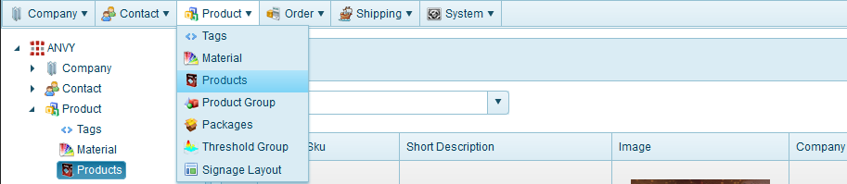**

You can saw this page **product**

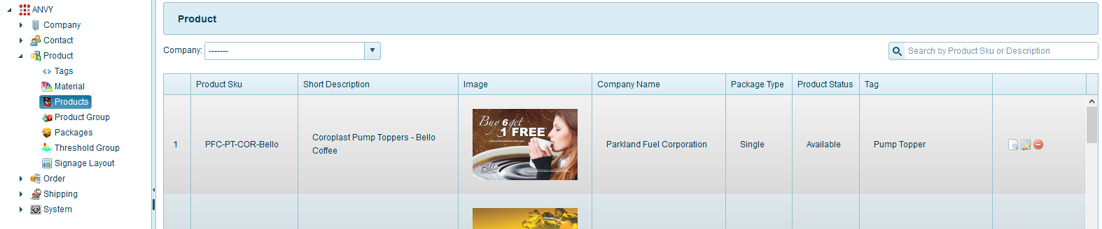

Please click the link **Add New** – menu top right from page **Products**



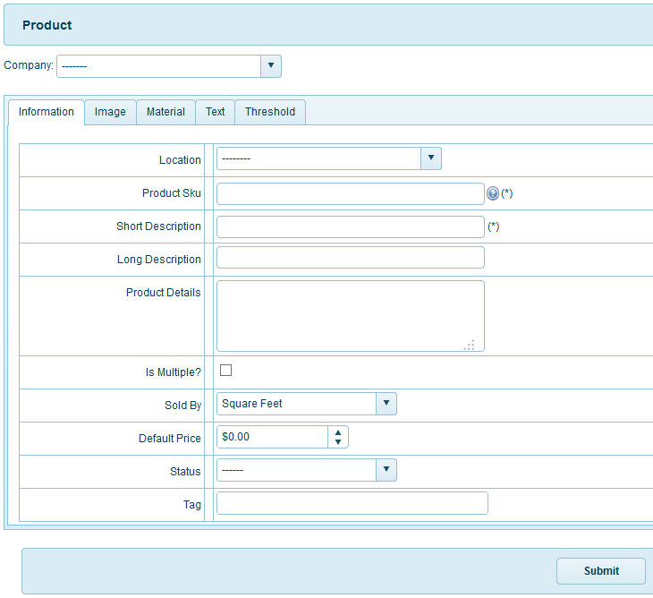

First you can choose company from field this, here you can see all company registed:

* **Company** – Select Company form list: (this field **required**)  
  

You can see 5 table you need input (information, image, material, text, threshold):

In tab Information:

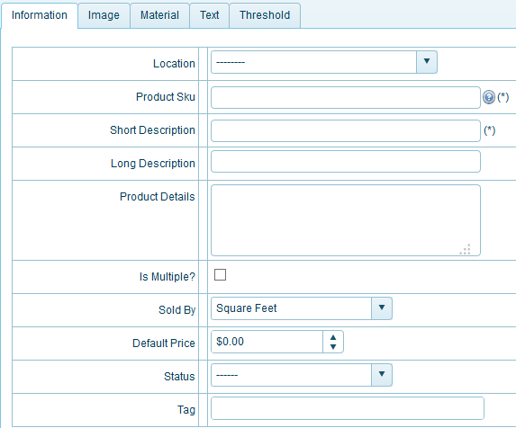

* Location: All location of company you selected



* Sold By: type sold by

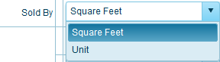

* **Status for Products** Avaliable or Not Avaliable
  + Avaliable: Status when you created will active similar products actived and   
    can use
  + 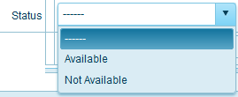Not Avaliable: as you do not create Products means products not use.

In tab Image:

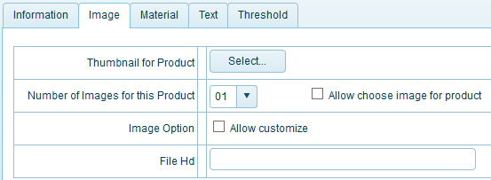

* **Thumbnail:** you can choose picture to thumnail for products to add new
* **Number of images for this products:** you can select number for products
* **Allow choose image for product:** allow choose images for products
* **Image Option:** you can allow customize, please click check box.

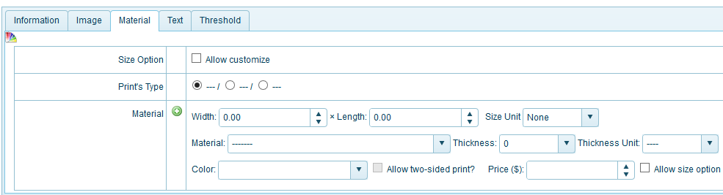

All information for products to add new

* **Size option:** you can allow customize, please click check box.
* **Prints type:** print type for this products
* **Material:** all information for products
  + Width
  + Length
  + Size unit
  + Material
  + Thickness
  + Thickness unit
  + Color material
  + Allow two-sided print: when you click checkbox color products will have two sided
  + Price: you can fix price for this products, if you want customer allow size option please click checkbox.

Or you choose material finish, field Thickness, Thickness Unit, Color will auto finish but you can edit all field if you want.

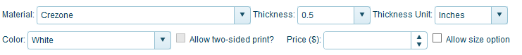

In tab Text:

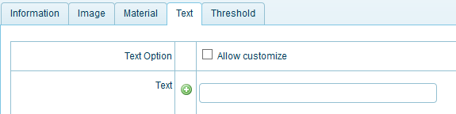

* **Text** option: allow customize text for products
* **Text**: you can add text you need and click icon  to add text for products.

In tab Threshold:

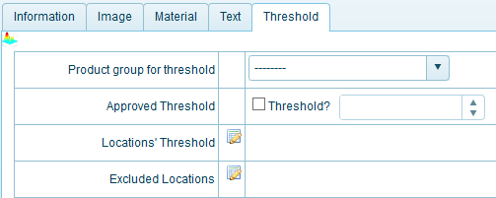

* **Product group for threshold**: you can choose group products for threshold from list

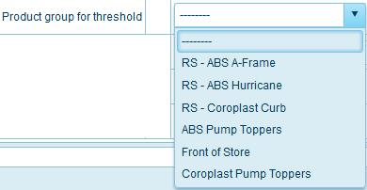

* **Approved Threshold:** you need click check box threshold and click number you want   
  Locations' Threshold: you can choose location threshold, please click icon  
   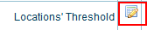  
    
  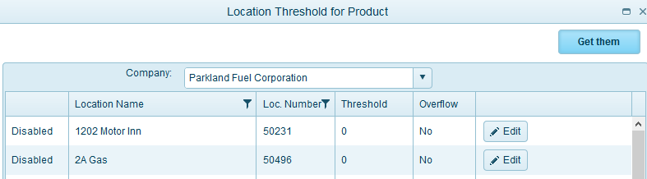  
  and then choose company you want use location threshold  
  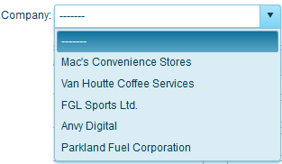  
  When you choose company, you can see all location for this company  
  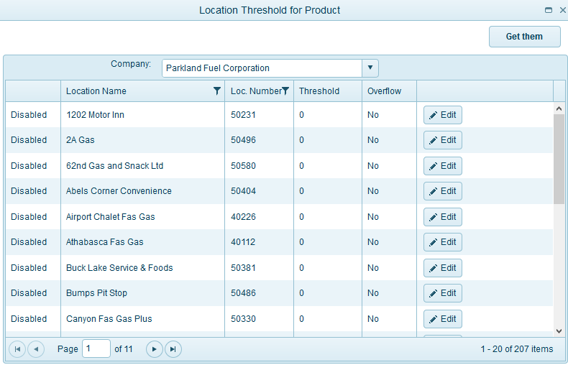  
    
  When you click icon  on field you will see filter lates:  
    
        
    
  Click button Edit 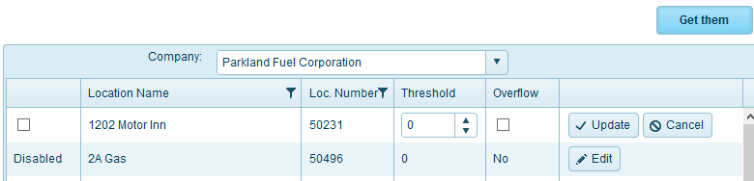  
  When Edit finish you can click button Update:  or cancel , and then click button Edit you can choose Location use select chekbox:   
    
    
  And then click button get them: 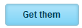, in Locations' Threshold you can see location you choose:  
  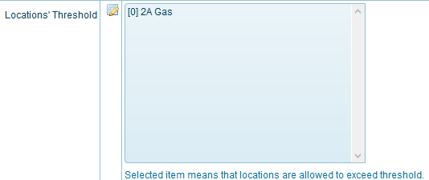  
  If you want delete location you can click button Edit  and click uncheck   
  and then click button get them: 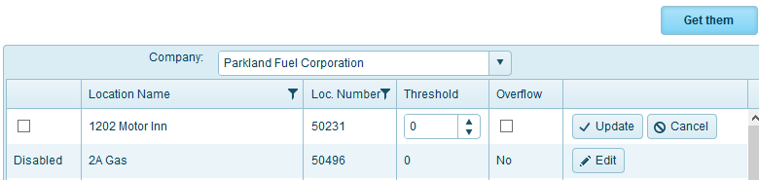  
  in Locations' Threshold you can see location you choose will delete: 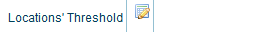  
  Excluded Locations: 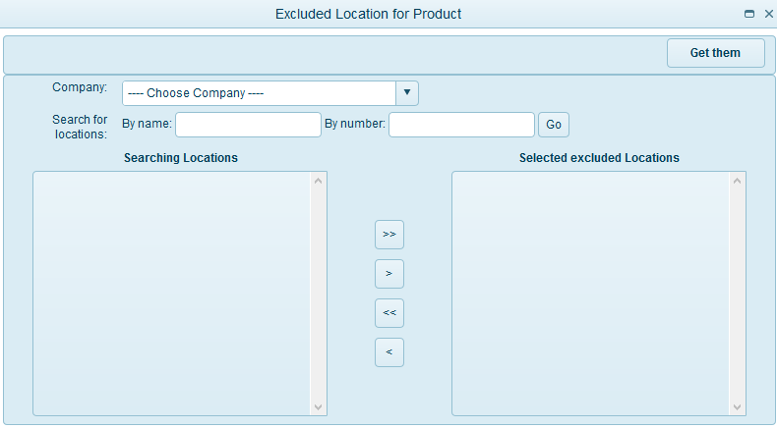  
  When you choose company, you can see all excluded Locations for this company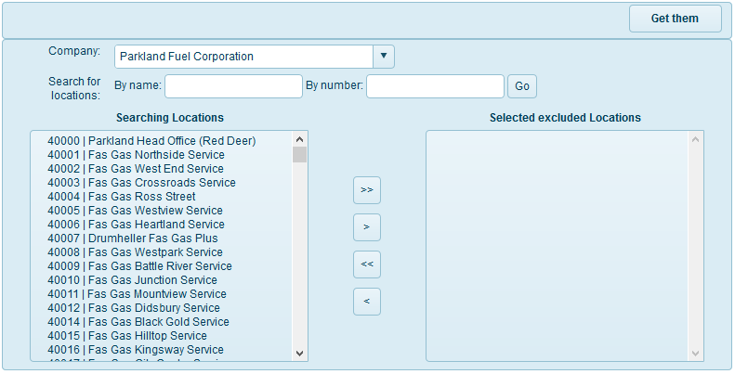You can click corresponding location and then click button  or click button  get all location searching to box selected excluded locations.  
    
  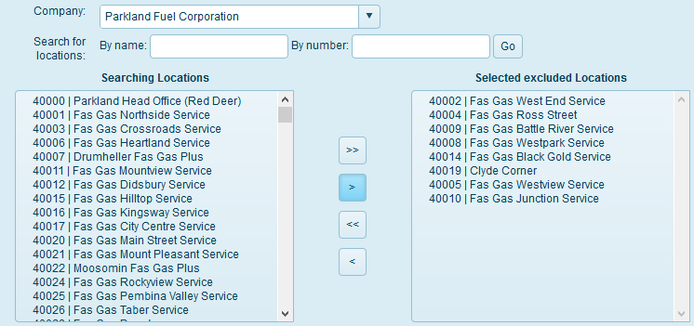  
  You can remove location selected, you click button  or button 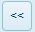 remove all location selected.  
  When you choose excluded locations you can click button 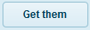 and you see:  
  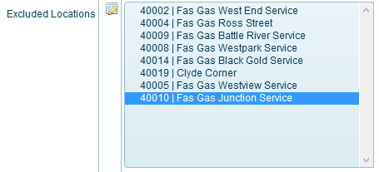  
  If you want remove selected excluded locations you can click 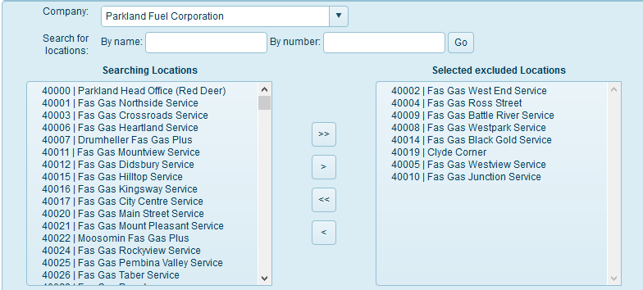You can remove location selected, you click button  or button  remove all location selected.

After you input, check all field finish. You can click button:  to finish add new material.

### Export

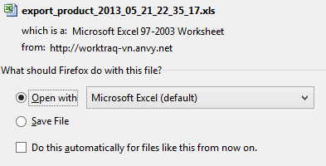

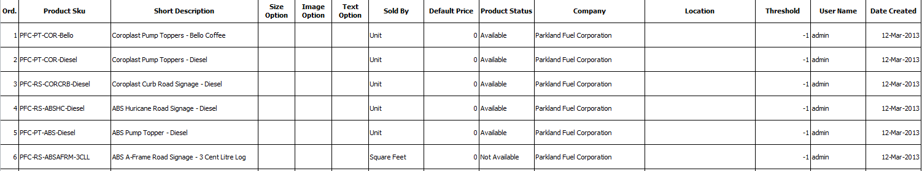

You want file contact Excel, please click icon Export

### Print

You want print file contact, please click icon print

### Content - page

 

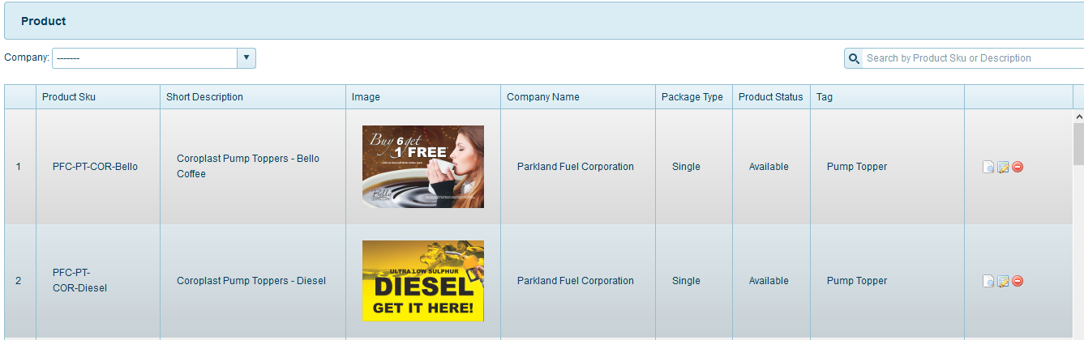

**Search products:**  
You can search products use field name or field company or both. Input products name or choose company or both you want to search here

 

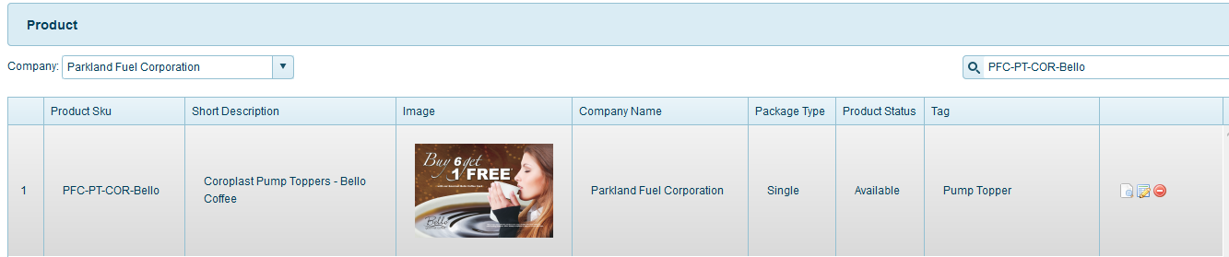



**Icon _view click ** View contact information

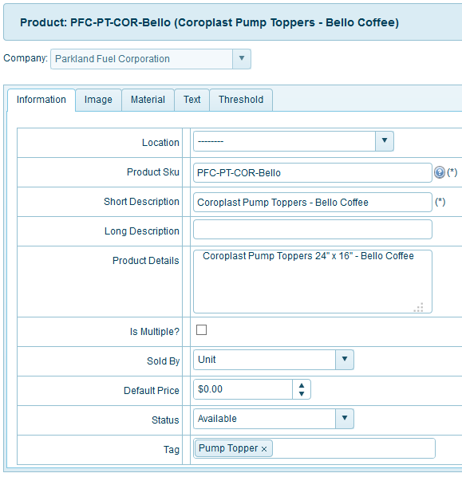

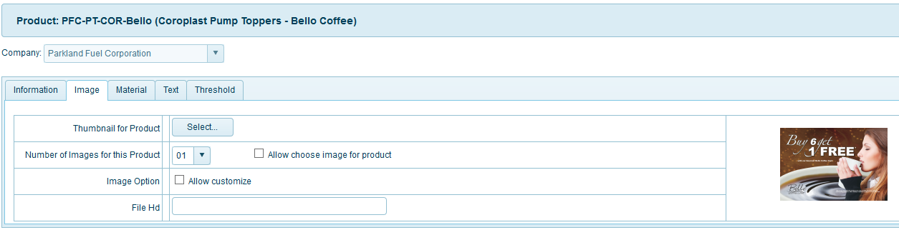

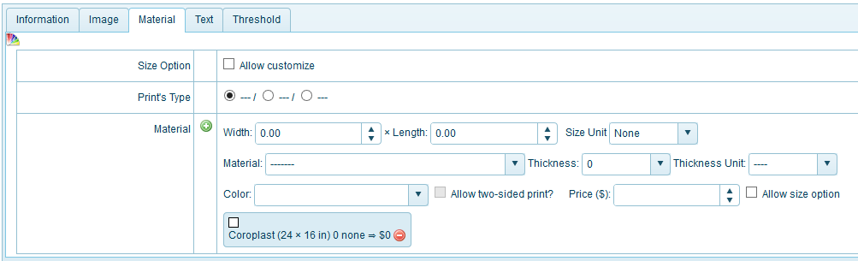

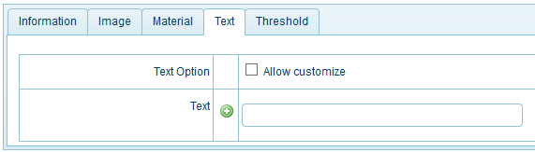

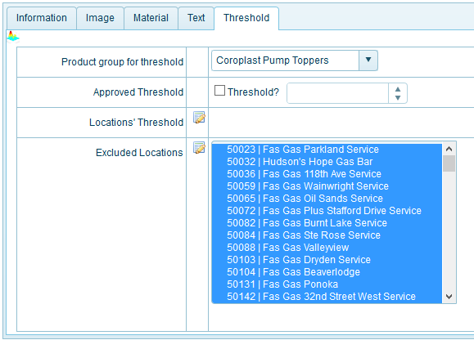

**Icon_edit click: ** if you want Edit products, please click icon_edit and then click ok, you will edit products selected.

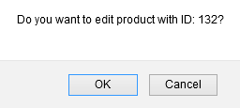

Here, you can not Edit Company name



All field similar page Add new (you can view lates **Add New**)

**Icon _ delete: ** to delete products selected, please click ok to delete products

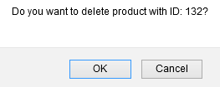

## **product – product Group**

Description: Group product

You can click from menu top Product 🡪 Product Group, or from menu left(when you clicked at least 1 menu from menu top) and then click menu you want, here Product Group:

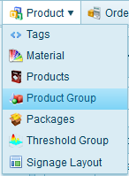 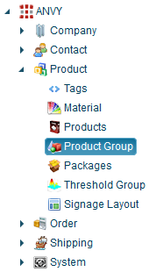

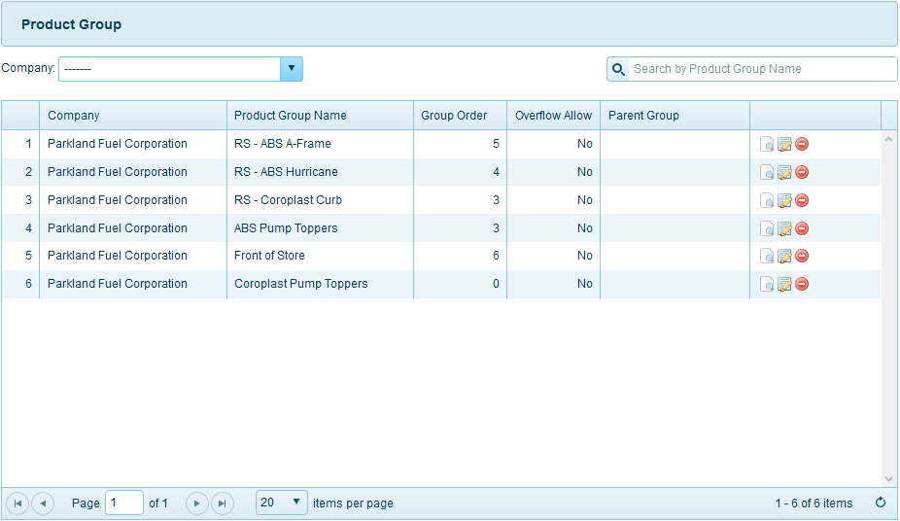

Function menu top right for page:



### Advanced

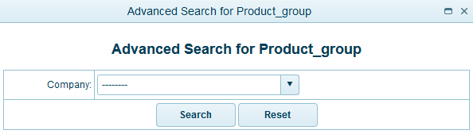

All company registed, you can see and then you need select 1 company you want search:



And then click button search:  or reset fileds selected by you 

### Add New

Please click the link **Product Group** from menu **Product  
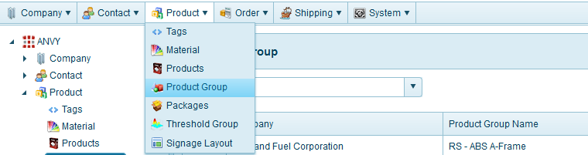**

You can saw this page **Product Group**

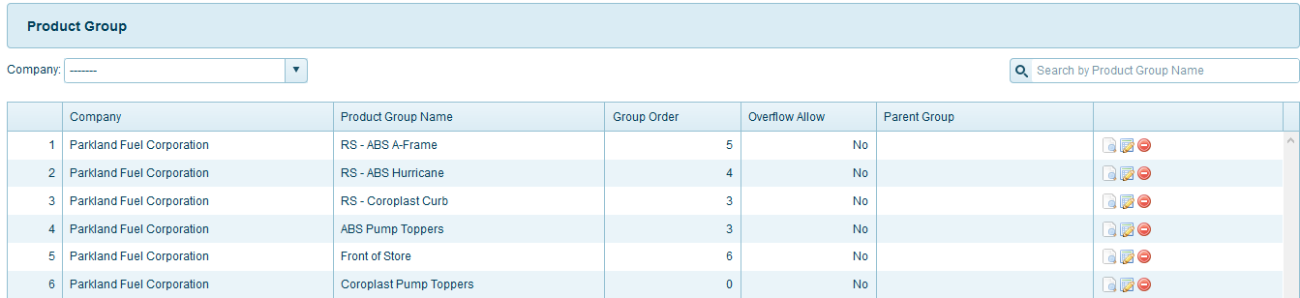

Please click the link **Add New** – menu top right from page **Product Group**



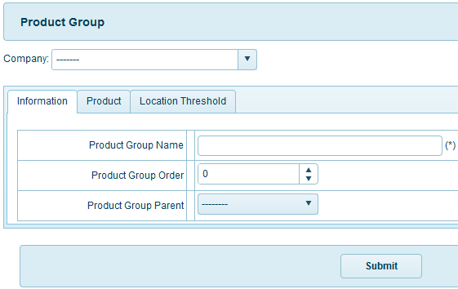

First you can choose company from field this, here you can see all company registed:

* **Company** – Select Company form list: (this field **required**)  
  

You can see 3 table you need input (information, product, location threshold):

In tab information:

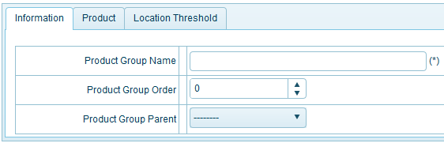

* **Product Group Parent:** all group product parent for company you choose

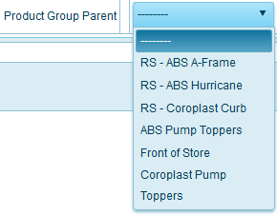

In tab information:

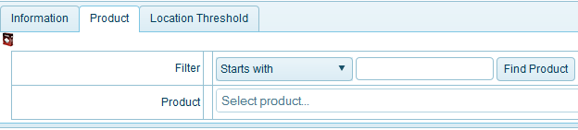

* **Filter:** you can find product on filter, filter have value(Starts with, containts, equal) 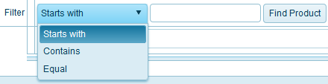  
  When you click button 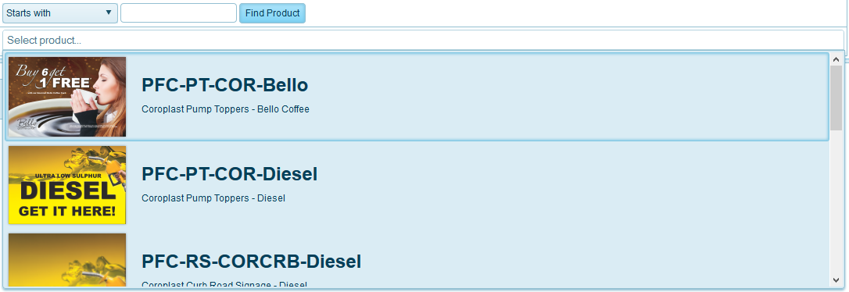  
  And then you choose product: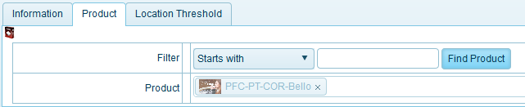If you want remove products selected you can click 

In tab location threshold:

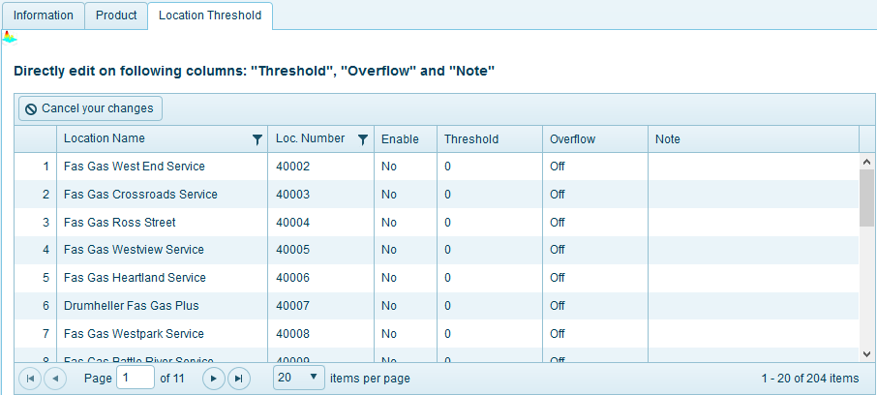

* When you click icon  on field you will see filter lates:  
      

After you input, check all field finish. You can click button:  to finish add new Product group.

### Export

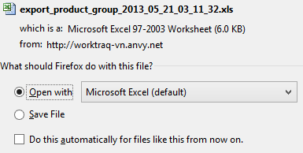

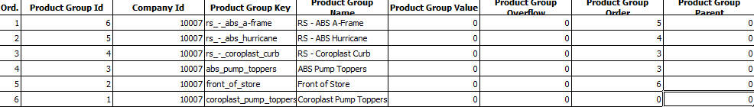

You want file contact Excel, please click icon Export

### Print

You want print file contact, please click icon print

### Content - page

 

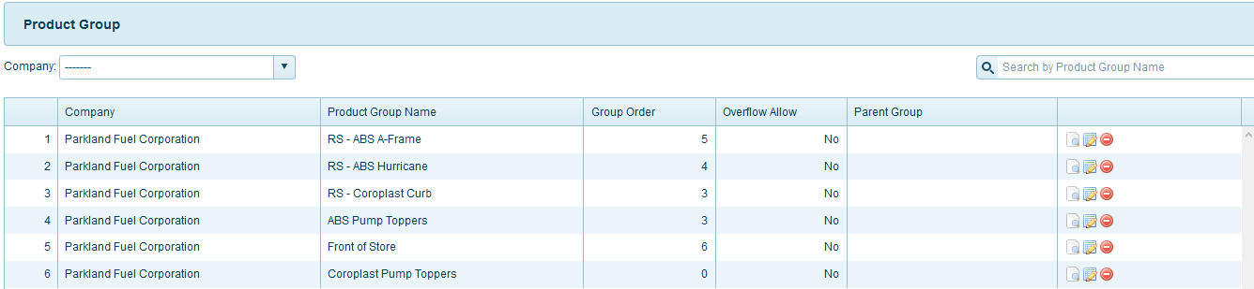

**Search products group:**  
You can search products group use field name or field company or both. Input products group name or choose company or both you want to search here

 

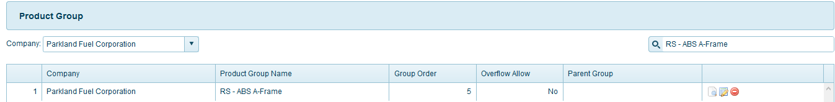



**Icon _view click ** View products group information

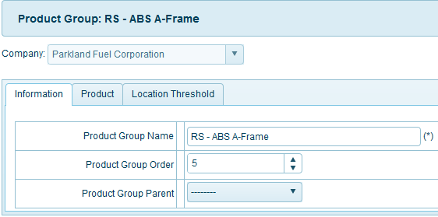

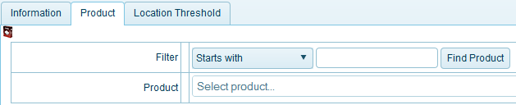

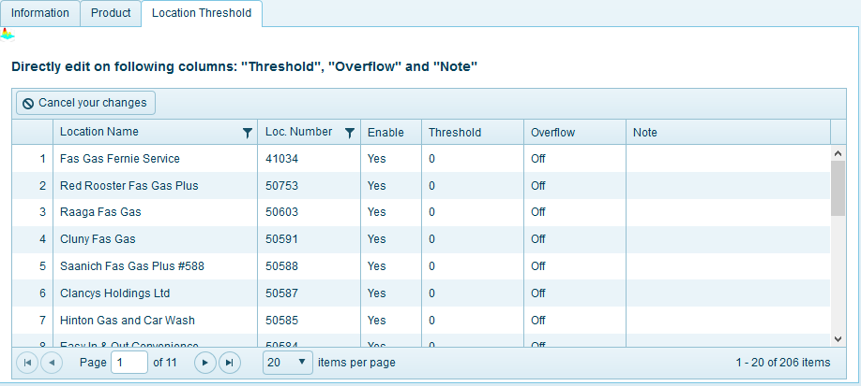

**Icon_edit click: ** if you want Edit products group, please click icon_edit and then click ok, you will edit products group selected.

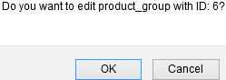

Here, you can not Edit Company name



All field similar page Add new (you can view lates **Add New**)

**Icon _ delete: ** to delete products group selected, please click ok to delete products group

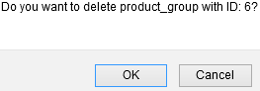

## **product – packages**

Description: Not avaliable.

You can click from menu top Product 🡪 Packages:

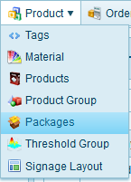

## **product – threshold group**

Description: threshold group of product in allocate to locations

You can click from menu top Product 🡪 Threshold group, or from menu left(when you clicked at least 1 menu from menu top) and then click menu you want, here Threshold group:

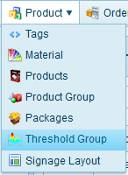 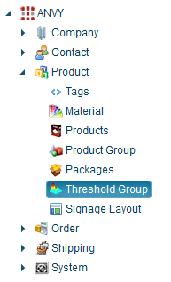

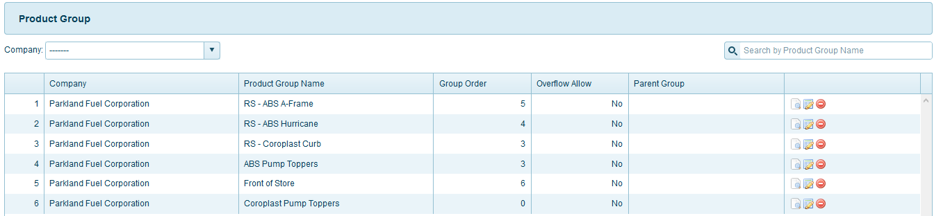

Function menu top right for page:

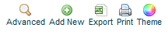

### Advanced

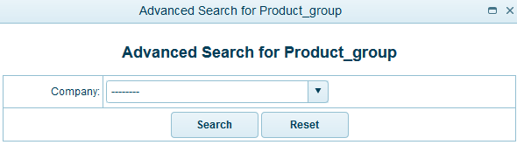

All company registed, you can see and then you need select 1 company you want search:



And then click button search:  or reset fileds selected by you 

### Add New

Please click the link **Threshold Group** from menu **Product  
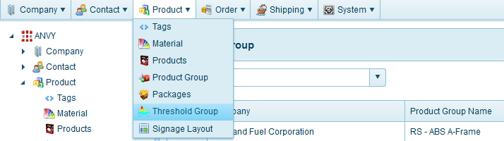**

You can saw this page **Threshold Group**



Please click the link **Add New** – menu top right from page **Threshold Group**



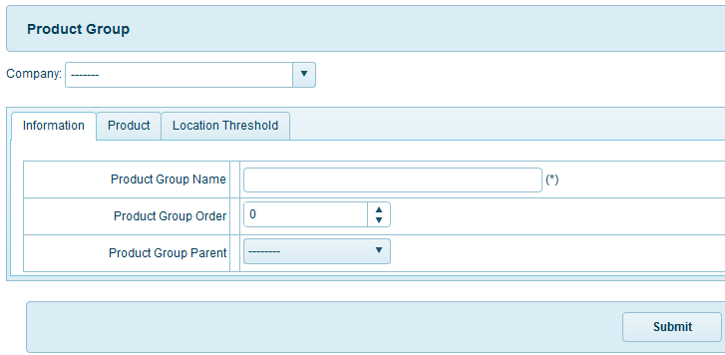

First you can choose company from field this, here you can see all company registed:

* **Company** – Select Company form list: (this field **required**)  
  

You can see 3 table you need input (information, product, location threshold):

In tab information:

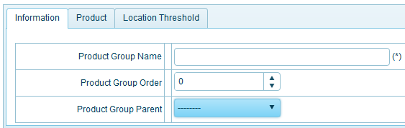

* **Product group order:** number product group you can choose
* **Product group parent:** product group parent you select in list for product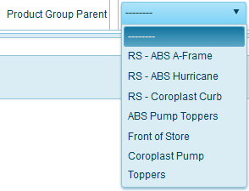

In tab product:

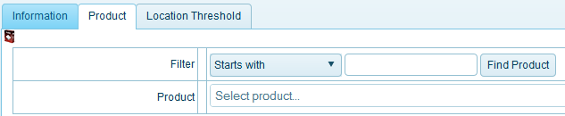

* **Filter:** you can find product on filter, filter have value(Starts with, containts, equal)   
  When you click button   
  And then you choose product:If you want remove products selected you can click 

In tab location threshold:

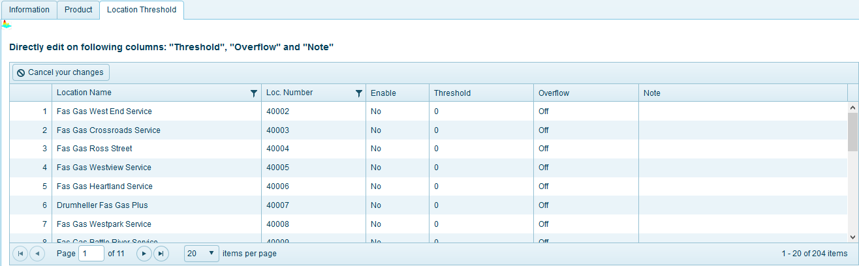

* When you click icon  on field you will see filter lates:  
      

After you input, check all field finish. You can click button:  to finish add new threshold group.

### Export

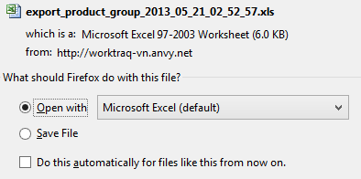

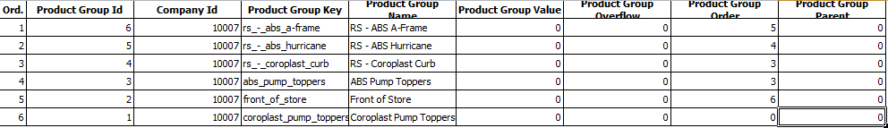

You want file contact Excel, please click icon Export

### Print

You want print file contact, please click icon print

### Content - page

 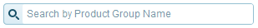



**Search products group:**  
You can search products group use field name or field company or both. Input products group name or choose company or both you want to search here

 





**Icon_view click ** View Threshold group information

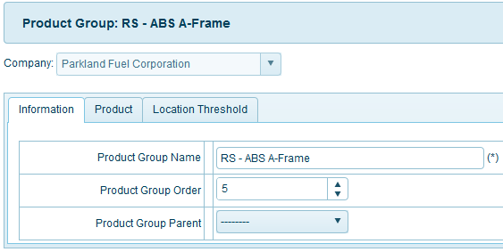

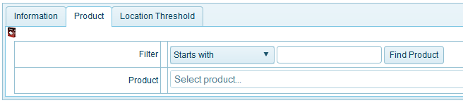

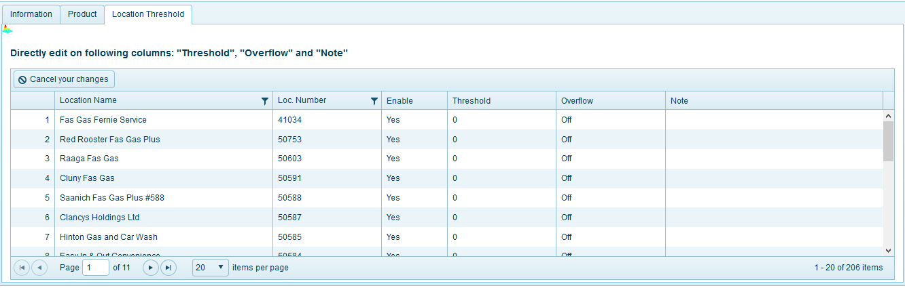

**Icon _edit click: ** if you want Edit threshold group, please click icon_edit and then click ok, you will edit threshold group selected.

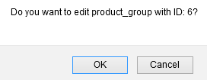

Here, you can not Edit Company name



All field similar page Add new (you can view lates **Add New**)

**Icon _ delete: ** to delete threshold group selected, please click ok to delete threshold group

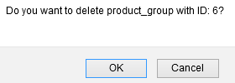

## **order – order**

Description: Customer order information  
If you want “Create Dispatch” first you have tracking company or you need created tracking company - **LINK**

You can click from menu top Order 🡪 Order, or from menu left (when you clicked at least 1 menu from menu top) and then click menu you want, here Order:

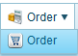 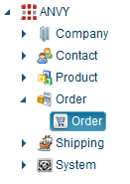

This part of the system will show all the order of users

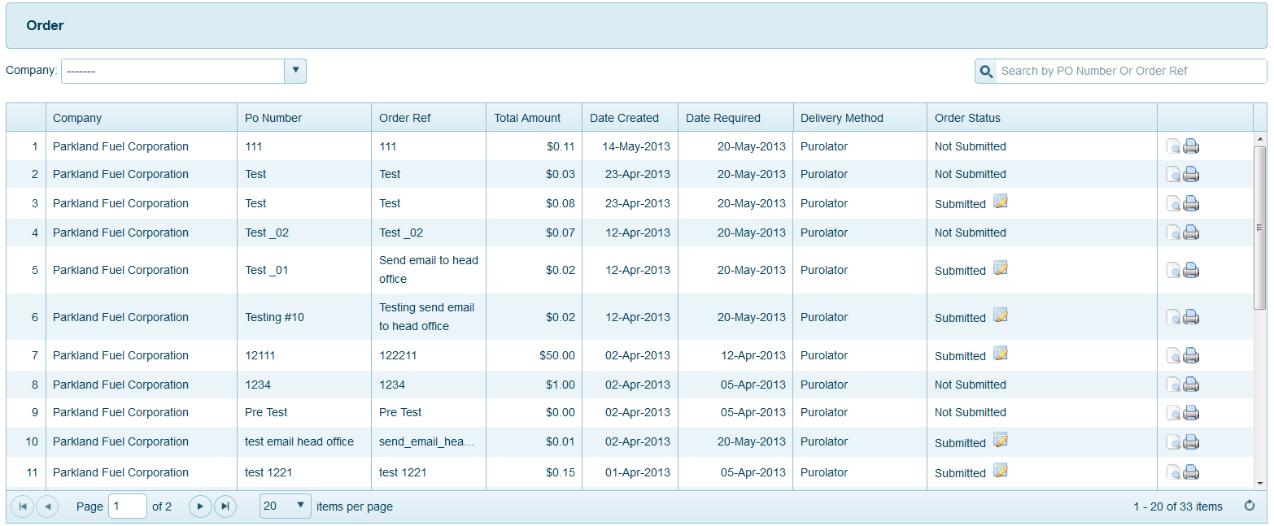

Function menu top right for page:

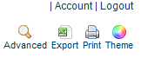

### Advanced

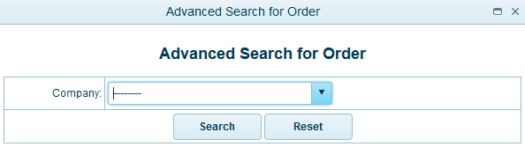

This part of the system is to manage the order from users, so you can’t add order or edit or delete user’s order. To search order by company choose company name on the drop down company



On the box you will see list of all company cooperate with Anvy, Choose company you want to view and system will filter all the order of company you choose

### Export





You want file contact Excel, please click icon Export

### Print

You want print file contact, please click icon print

### Content - page

 

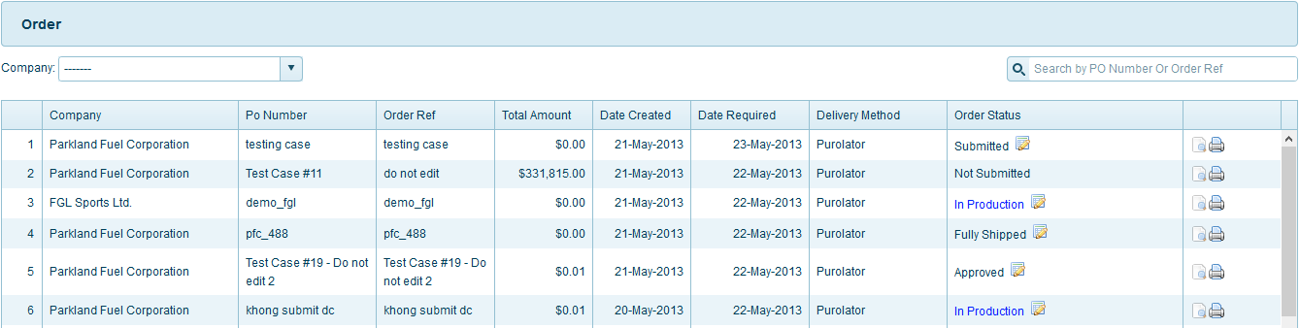

**Search Orders:**  
To search for a specify order you can’t type Order Number or Order Ref on the Search box on the top right of the page

 

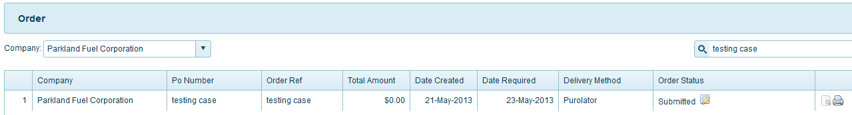

For example I search orders with Order Number or Order Ref contain “Test” of company “Parkland Fuel Corporation”.

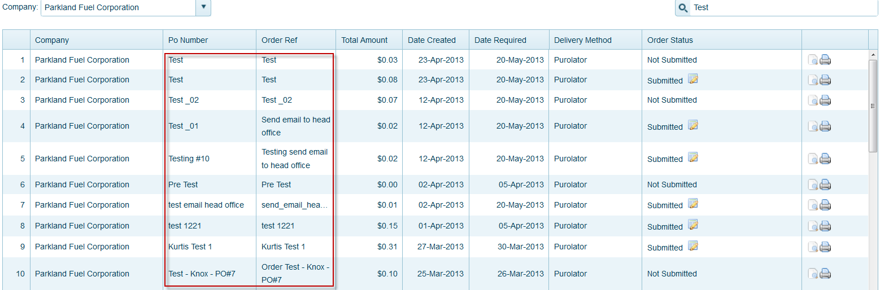

Status order’s have 3 type: “submitted, not submitted and pending”.



You can only view not submitted and pending orders but with submitted order you can edit order status

When click button  you can see: 

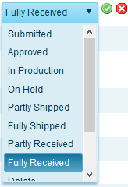

* Submitted
* Approved
* In Production (you can see lates LINK)
* Approved: Your order is accept and wait for your turn
* In Production: Your order is producing
* On Hold: Your order is hold for checking
* Partly Shipped: Your order is shipping partly
* Full Shipped: Your order is shipping full order
* Partly Received: Your order was received partly
* Fully Received: Your order was full received
* Delete: Your order was deleted
* Void: Your order was voided
* Canceled: Your order was canceled



**Icon_view click ** View order information

Information tab: contain all information of order and shipping contact

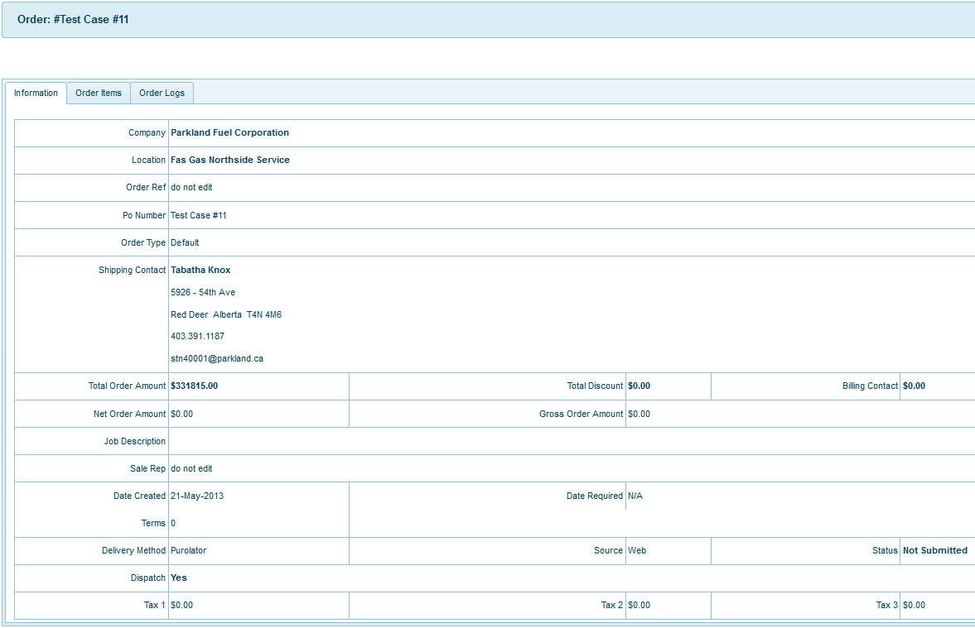

Order items tab: contain information of order’s item like name, quantity, total…

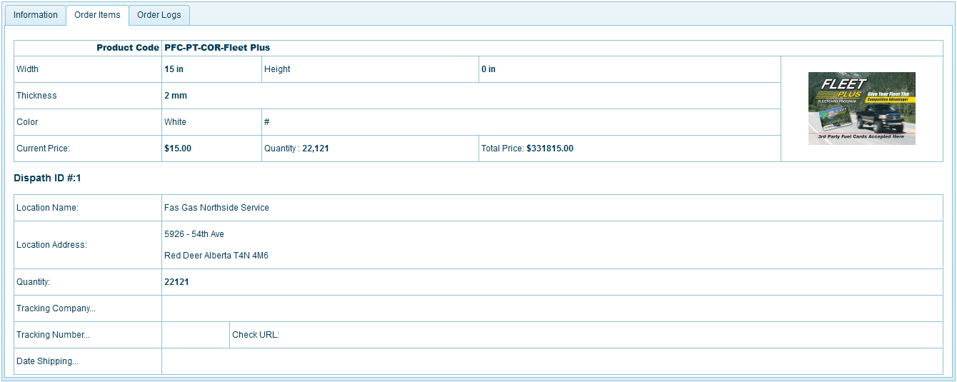

Order logs tab: show all information of order’s users. What they did before submit order



**Icon _edit click:** if you want Edit order, please click icon_edit and then click ok, you will edit order selected

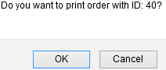

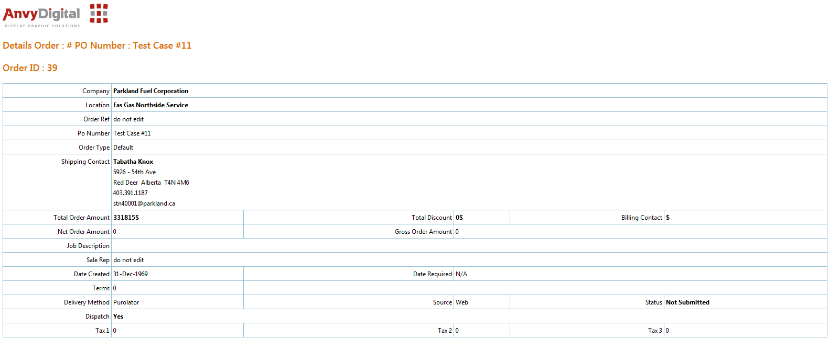

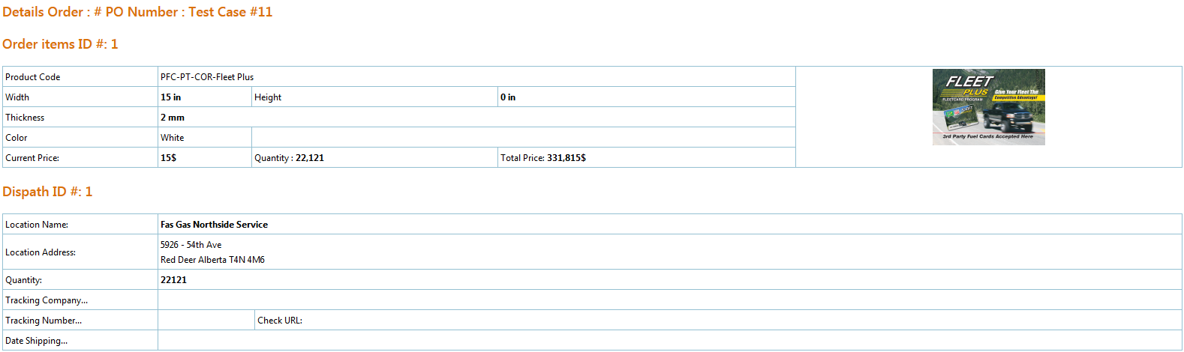

### In Production:

**Step 1:** Choose “In Production” from “Submitted” order.

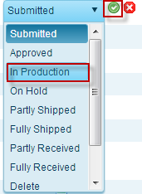

And then click button accpet:  or cancel you can click button 

**Step 2:** click on link after status changes



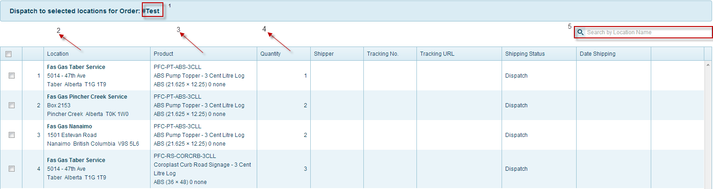

* 1 - Order Product Number
* 2 - Location information for shipping
* 3 - Product information to shipping
* 4 - Quantity to ship for each location
* 5 -Type location name here if you want search product shipping for location

Choose location you want to ship product then click “Create Dispatch”

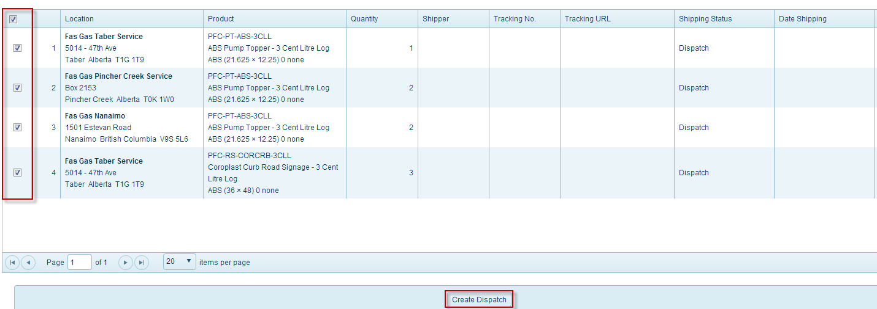

**Step 3:** fill all the require field

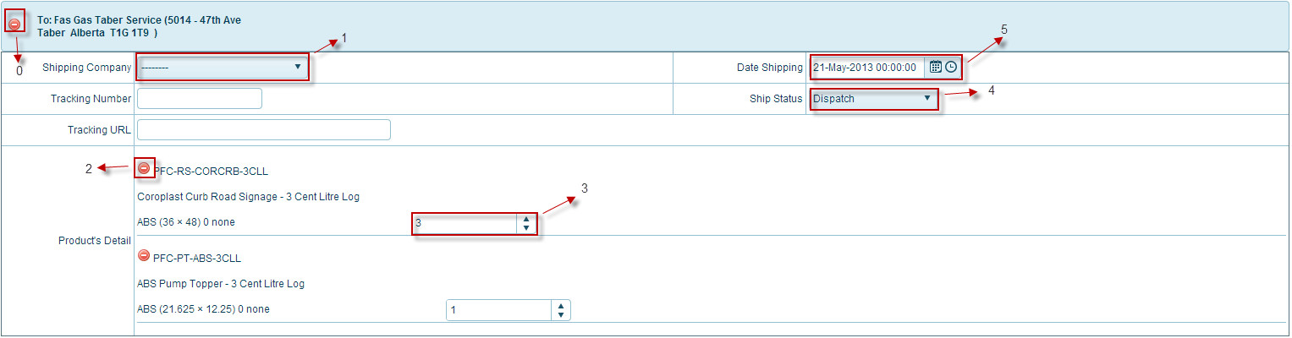

* 0 - Remove all tracking shipping 
* 1 - Choose shipping company to dispatch orders   
  (first you have tracking company or you need created tracking company - **LINK**)
* 2 - Remove product on tracking shipping
* 3 - Product quantity for shipping
* 4 - Date start dispatch
* 5 - Ship status

**Step 3.1 :** Shipping companies. Choose a shipping company cooperate with your company

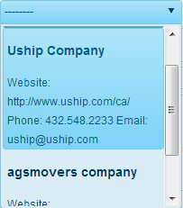

After choose shipping company, field “tracking url” and “tracking number” will auto fill with shipping company information

**Step 3.2 :** Choose status shipping

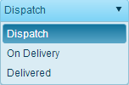

* **Dispatch**: dispatch to shipping company
* **On Delivery**: start delivering order to customer
* **Delivered**: Order was delivery

**Step 4:** Click Create Dispatch

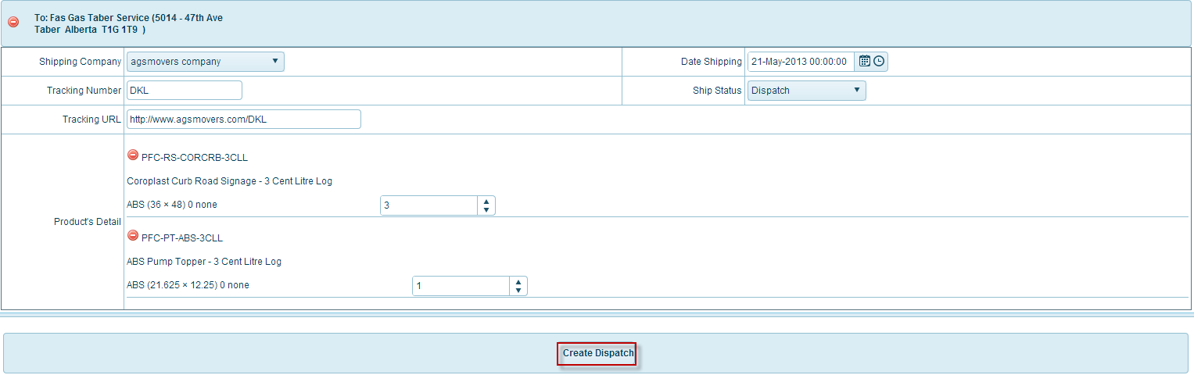

**Step 5:** Check order status



Because we dispatch part of the order so order status change to Partly Shipped

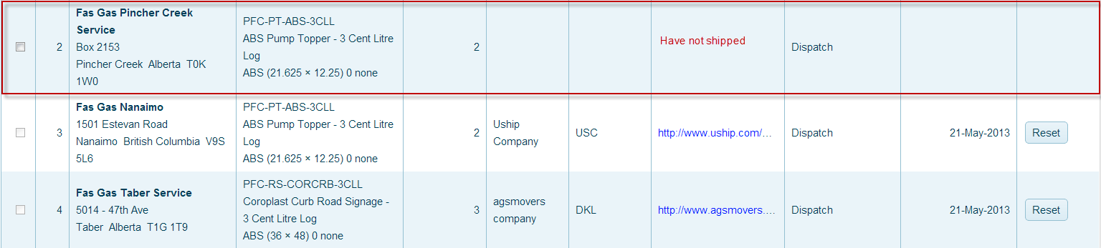

After we dispatch all part of order:



Final step: After customer received their order, we change order status to “Partly Received, Full Received

## **shipping – shipping**

Description: Customer Shipping information

You can click from menu top Shipping 🡪 Shipping, or from menu left(when you clicked at least 1 menu from menu top) and then click menu you want, here Tripping:

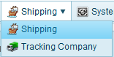 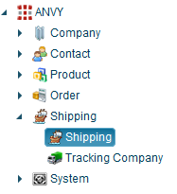

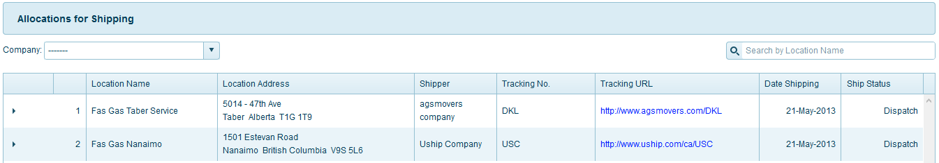

Function menu top right for page:

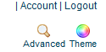

### Advanced

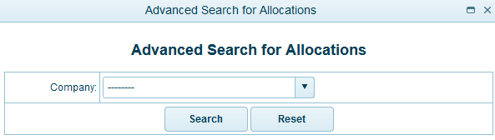

All company registed, you can see and then you need select 1 company you want search:



And then click button search:  or reset fileds selected by you 

List of shipping orders

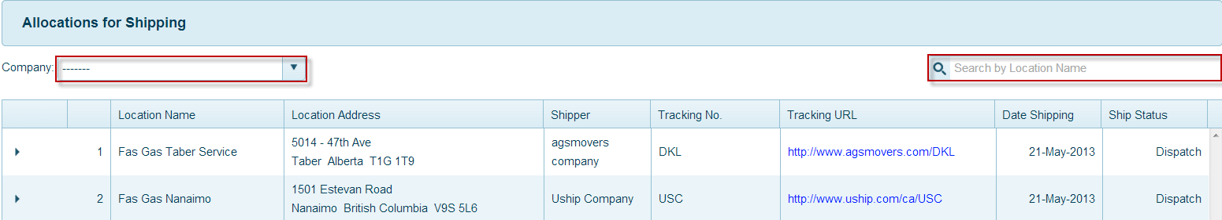

To search shipping by company, choose company from list Company

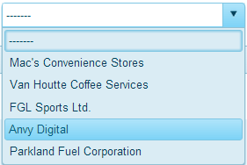

To search shipping location name, type location name on the location name field

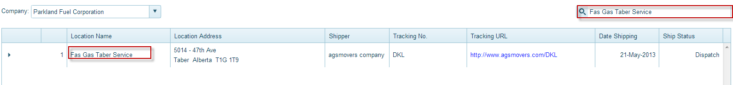

## **shipping – tracking company**

Description: Content all information of traccking company.

You can click from menu top Shipping 🡪 Tracking company, or from menu left(when you clicked at least 1 menu from menu top) and then click menu you want.  
Here Tracking company:

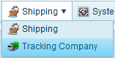

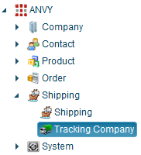

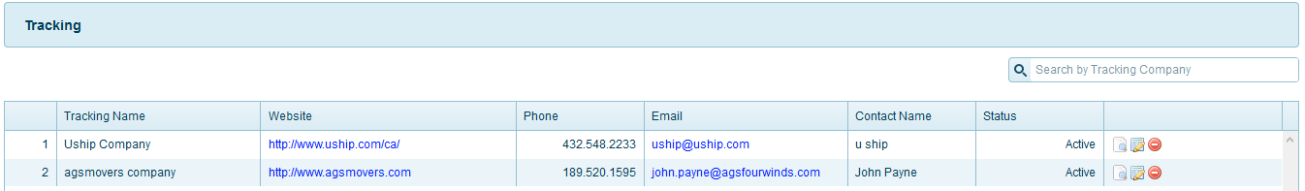



### Advanced

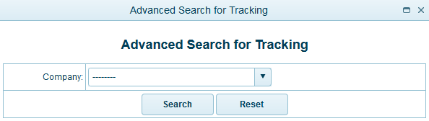

All company registed, you can see and then you need select 1 company you want search:



And then click button search:  or reset fileds selected by you 

### Add New

Please click the link **Tracking Company** from menu **Shipping  
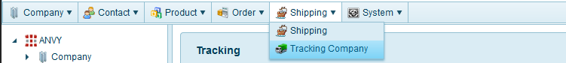**

You can saw this page **Tracking Company**

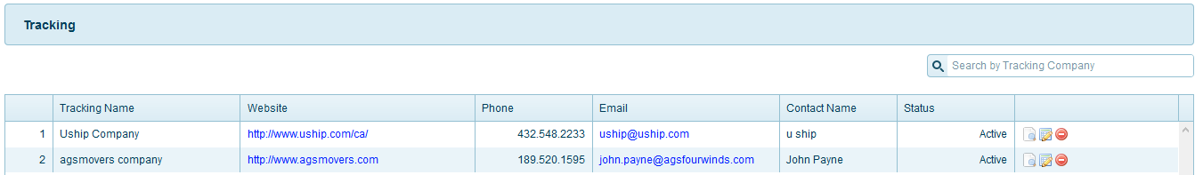

Please click the link **Add New** – menu top right from page **Tracking company**



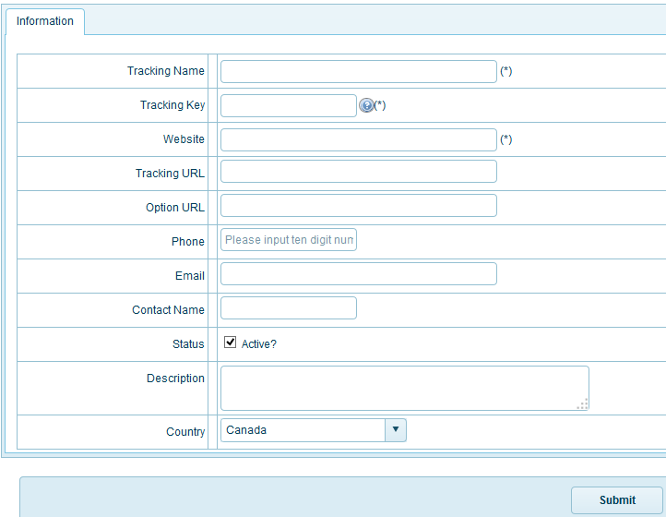

* **Tracking name:** name tracking
* **Tracking key:** key tracking use to know status for product of you
* **Tracking URL:**  URL tracking is use tracking key on tracking URL
* **Status for Tracking company** Active or not active
  + Active: Status when you created will active similar tracking company actived
  + Not active: Tracking company is not active.  
    

After you input, check all field finish. You can click button:  to finish add new tracking company.

### Export

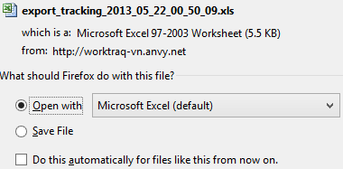



You want file contact Excel, please click icon Export

### Print

### 

You want print file contact, please click icon print

### Content - page

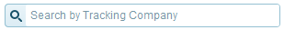

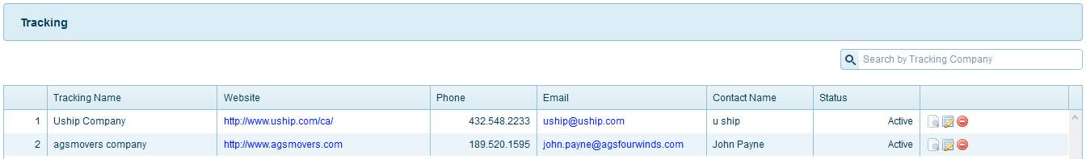

**Search Tracking company:**  
You can search tracking company use field name. Input tracking company name you want to search here



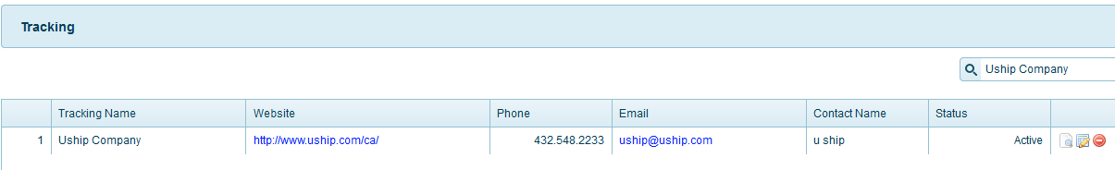



**Icon_view click ** View Tracking company information

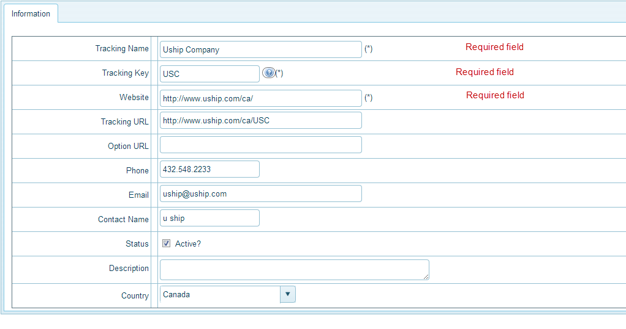

**Icon _edit click: ** if you want Tracking company, please click icon_edit and then click ok, you will edit tracking company selected.

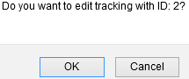

All field similar page Add new (you can view lates **Add New**)

**Icon _delete: ** to delete tracking company selected, please click ok to delete tracking company

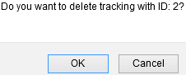

## **system – province**

Description: save all name, city, country.

You can click from menu top System 🡪 Province, or from menu left(when you clicked at least 1 menu from menu top) and then click menu you want, here Province:

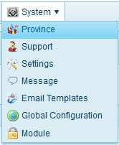 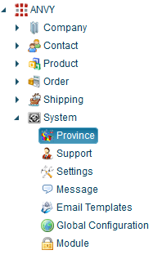

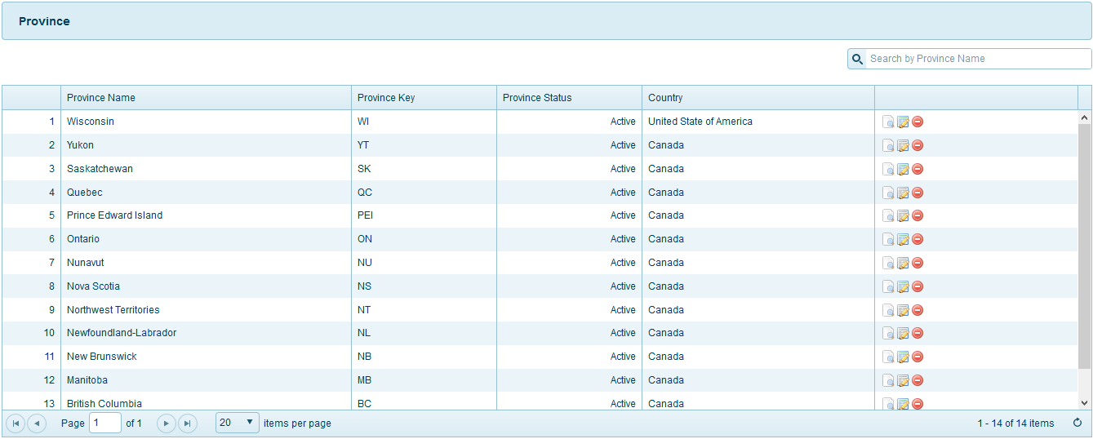

Function menu top right for page:



### Advanced

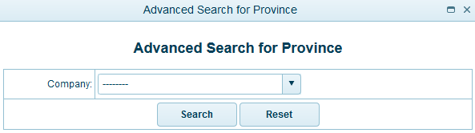

All company registed, you can see and then you need select 1 company you want search:



And then click button search:  or reset fileds selected by you 

### Add new

Please click the link **Province** from menu **System  
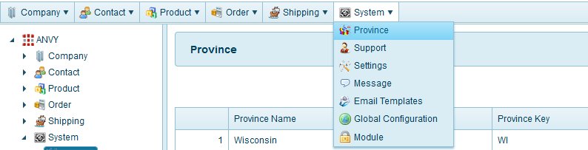**

You can saw this page **Province**

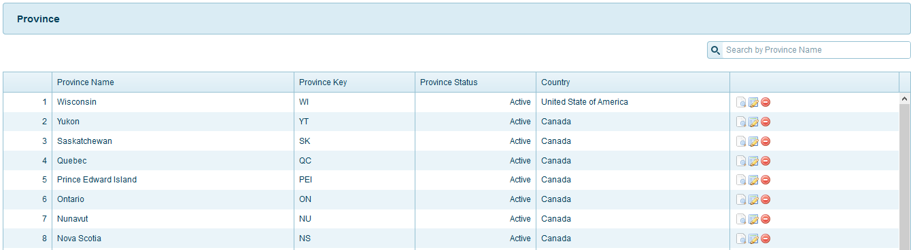

Please click the link **Add New** – menu top right from page **Province**



In tab information:

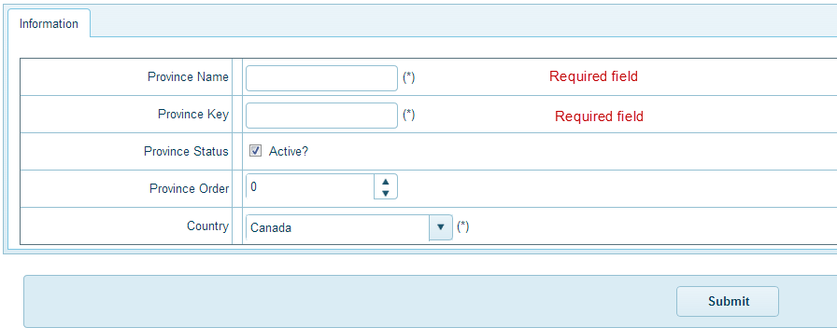

* **Province name:** this field **required**, you need input
* **Province key:**
* **Province status**
  + Active: status of province active mean add new successful
  + Not active: status of province not active.
* **Province Order:** you choose number for Province order
* **Country:** this field **required**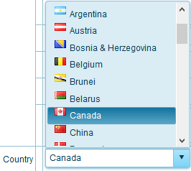

### Export

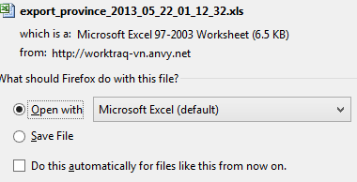

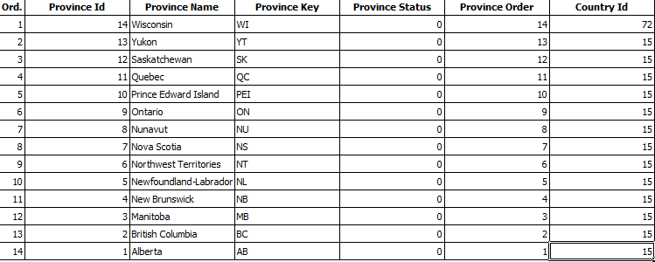

You want file contact Excel, please click icon Export

### Print

You want print file contact, please click icon print

### Content - page

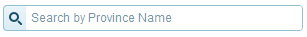

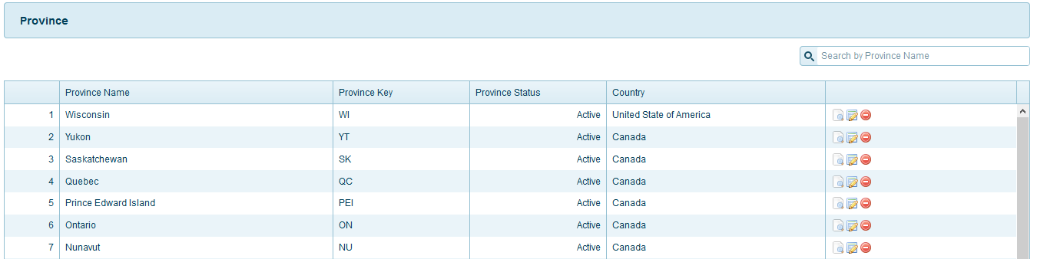

**Search Province:**  
You can search province use field name. Input province name you want to search here







**Icon_view click ** View Province information

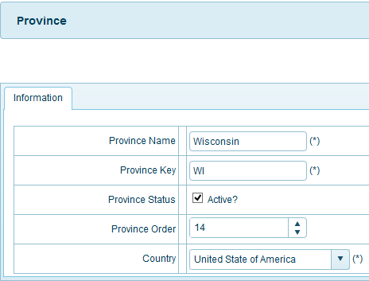

**Icon _edit click: ** if you want Edit province, please click icon_edit and then click ok, you will edit province selected.

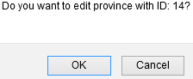

All field similar page Add new (you can view lates **Add New**)

**Button_ delete: ** to delete province selected, please click ok to delete province

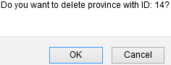

## **system – Support**

Description: This part of the system show all the feedback send by customers.

You can click from menu top System 🡪 Support, or from menu left(when you clicked at least 1 menu from menu top) and then click menu you want, here Support:

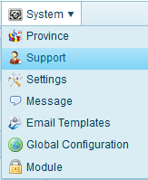 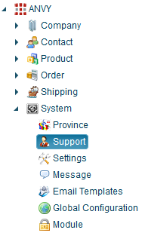

This part of the system show all the feedback send by customers

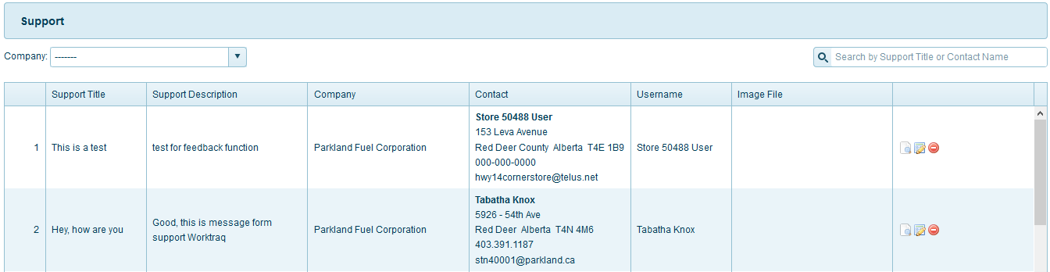

Function menu top right for page:



### Advanced

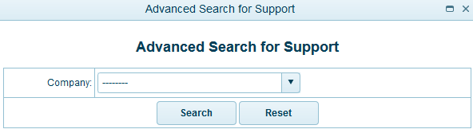

All company registed, you can see and then you need select 1 company you want search:



And then click button search:  or reset fileds selected by you 

### Add new

Please click the link **Support** from menu **System  
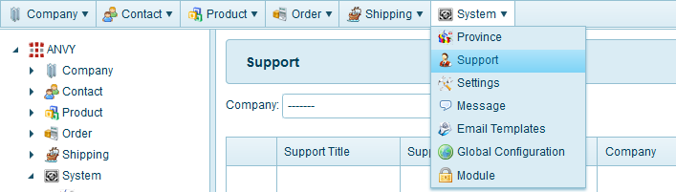**

You can saw this page **Support**

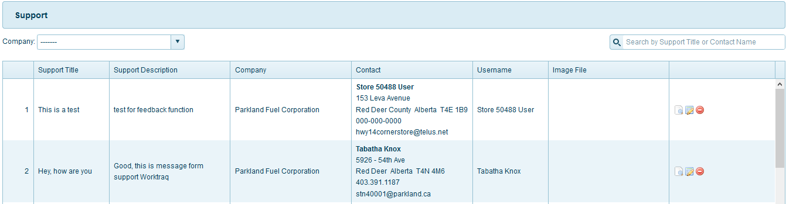

Please click the link **Add New** – menu top right from page **Support**



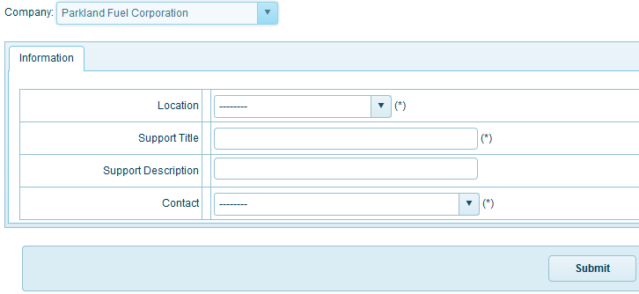

First you can choose company from field this, here you can see all company registed:

* **Company** – Select Company form list: (this field **required**)  
  

In tab information:

* **Location**: All location of company you selected  
  
* **Contact:** All contact for company you selected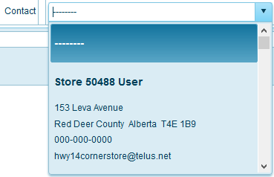

After you input, check all field finish. You can click button:  to finish add new material.

### Export





You want file contact Excel, please click icon Export

### Print

### 

You want print file contact, please click icon print

### Content - page

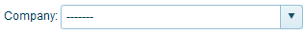 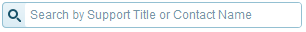

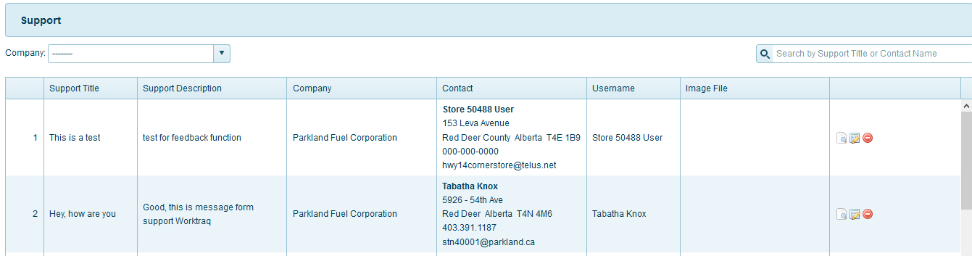

**Search Support:**  
You can search support use field name or field company or both. Input support title, contact name or choose company or both you want to search here:

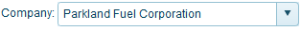 

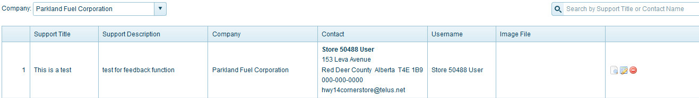

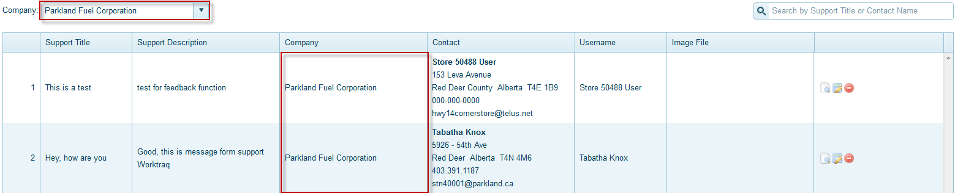

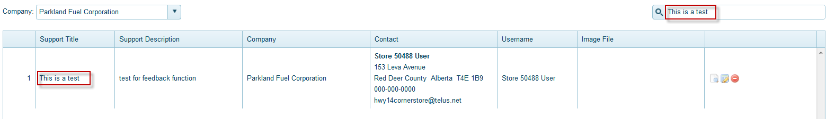



**Icon _view click ** View Support information

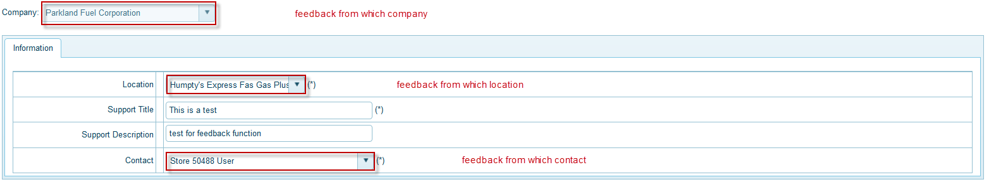

**Icon _edit click: ** if you want Edit support, please click icon_edit and then click ok, you will edit support selected

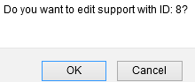

Here, you can not Edit Company name



All field similar page Add new (you can view lates **Add New**)

**Icon_ delete:  to delete Support selected**

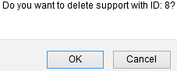

## **system – settings**

You can click from menu top System 🡪 Settings, or from menu left(when you clicked at least 1 menu from menu top) and then click menu you want, here Settings:

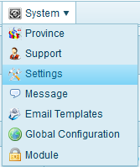 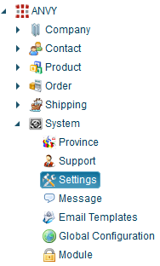

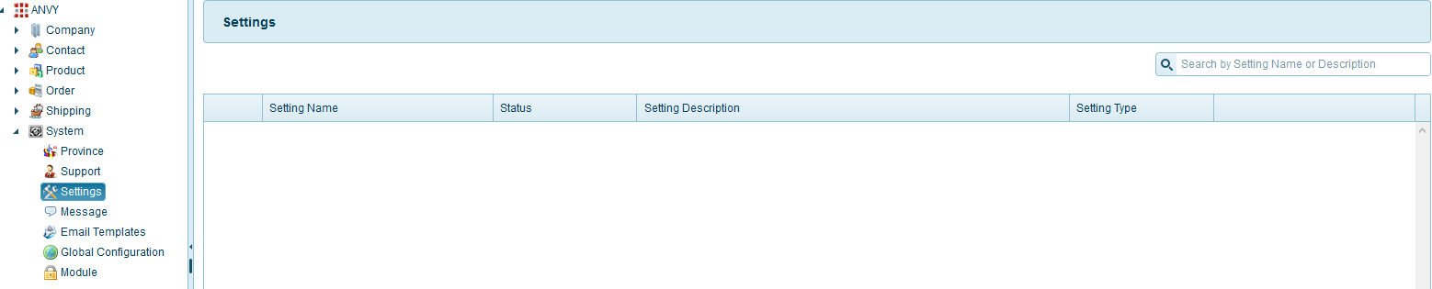

Function menu top right for page:



### Advanced

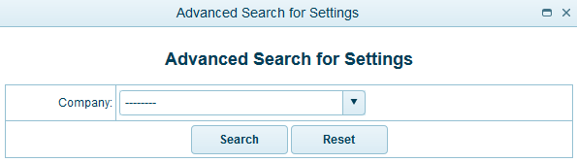

All company registed, you can see and then you need select 1 company you want search:



And then click button search:  or reset fileds selected by you 

### Add New

Please click the link **products** from menu **product  
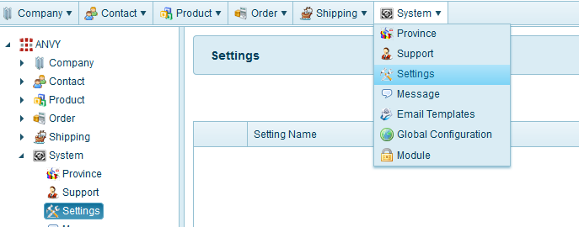**

You can saw this page **product**



Please click the link **Add New** – menu top right from page **Products**



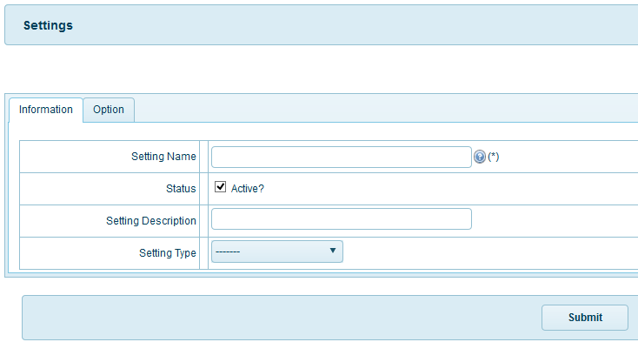

In tab information:

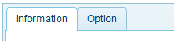

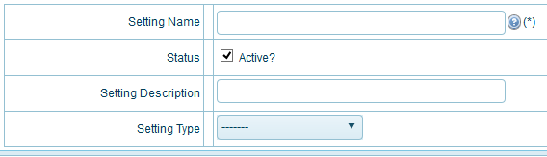

* **Setting name:** name setting – to help you know this setting to do.
* **Status for settings** Active or not active
  + Active: Status when you created will active similar settings actived
  + Not active: settings is not active.  
    
* **Setting description:** description for settings
* **Setting type:** 
  + Develop**:** setting for developer
  + Template: setting for user use template 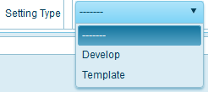

In tab option:

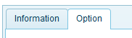



If you want create new setting, please click button “CREATE NEW SETTING” and then you input all filed you can click button ”UPDATE”.

After you input, check all field finish. You can click button: “SUBMIT” to finish add new settings.

### Export





You want file contact Excel, please click icon Export

### Print

You want print file contact, please click icon print

## **system – message**

Description: This part of system is content all message such as: error login, success login, success edit order….

You can click from menu top System 🡪 Message, or from menu left(when you clicked at least 1 menu from menu top) and then click menu you want, here Message:

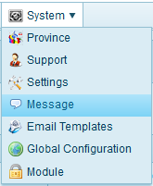 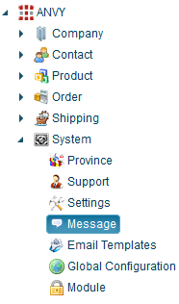

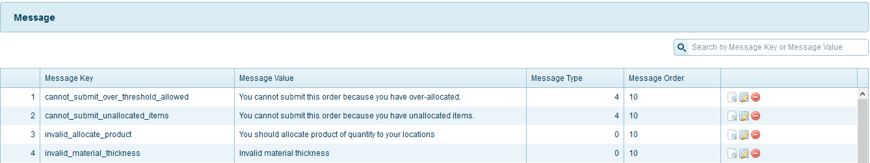

Function menu top right for page:



### Advanced

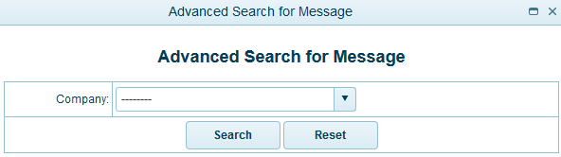

All company registed, you can see and then you need select 1 company you want search:



And then click button search:  or reset fileds selected by you 

### Add new

Please click the link **Message** from menu **System  
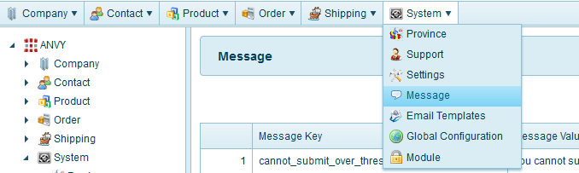**

You can saw this page **Message**

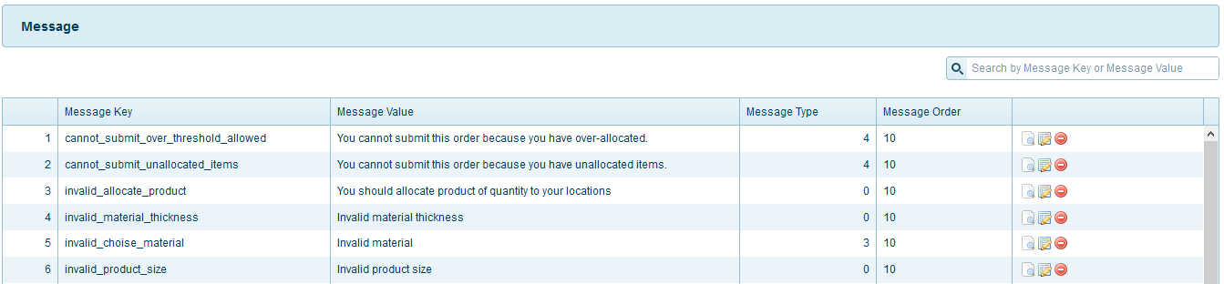

Please click the link **Add New** – menu top right from page **Message**



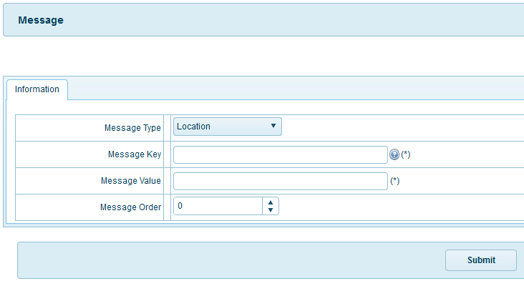

* **Message type:** Choose what message will use for function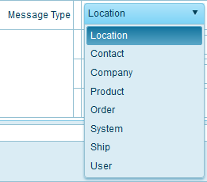
* **Message key:** key message is unique
* **Message value:** value for message
* **Message order**: you can choose number for order message

After you input, check all field finish. You can click button:  to finish add new material.

### Export



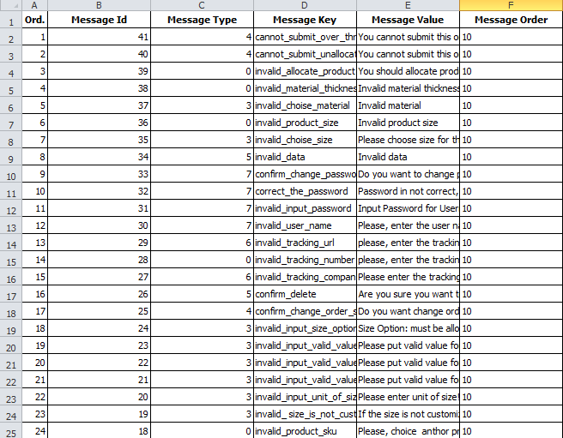

You want file contact Excel, please click icon Export

### Print

You want print file contact, please click icon print

### Content - page

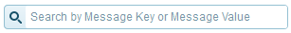



**Search Message:**  
You can search message use field name. Input message name you want to search here



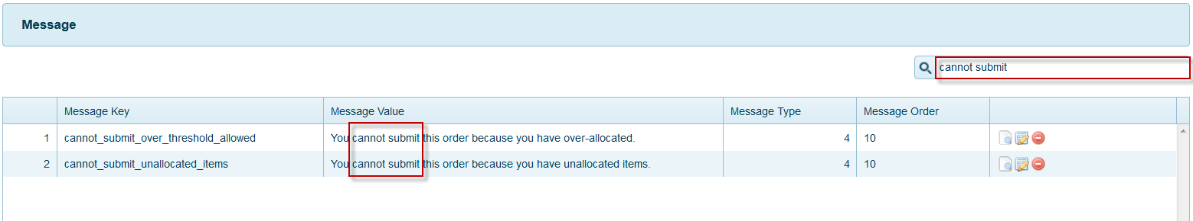



**Icon_view click ** View Message information

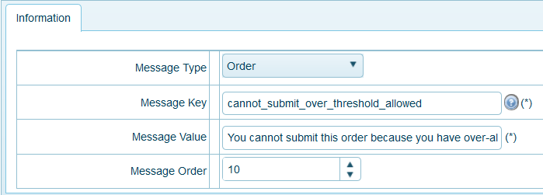

**Icon _edit click: ** if you want Edit message, please click icon_edit and then click ok, you will edit message selected.

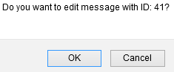

All field similar page Add new (you can view lates **Add New**)

**Icon_delete: ** to delete message selected, please click ok to delete message

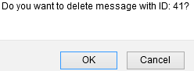

## **system – Email Templates**

Description: This part show all email template auto send for customer

You can click from menu top System 🡪 Email Templates, or from menu left(when you clicked at least 1 menu from menu top) and then click menu you want, here Email Templates:

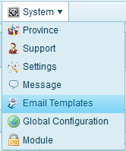 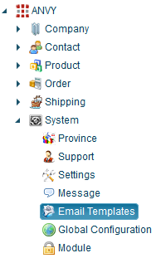

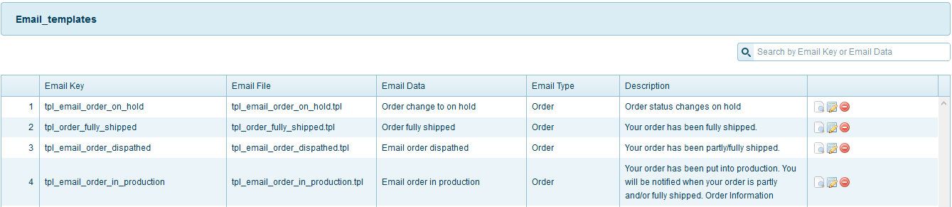

Function menu top right for page:



### Advanced

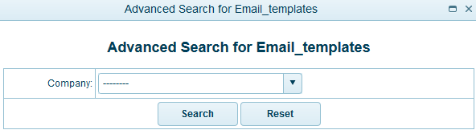

All company registed, you can see and then you need select 1 company you want search:



And then click button search:  or reset fileds selected by you 

### Add new

Please click the link **Email Templates** from menu **System  
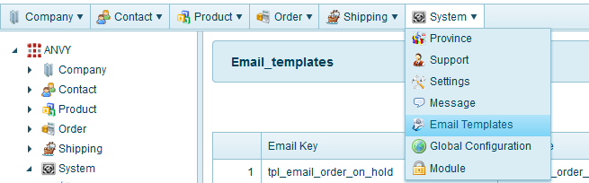**

You can saw this page **Email Templates**

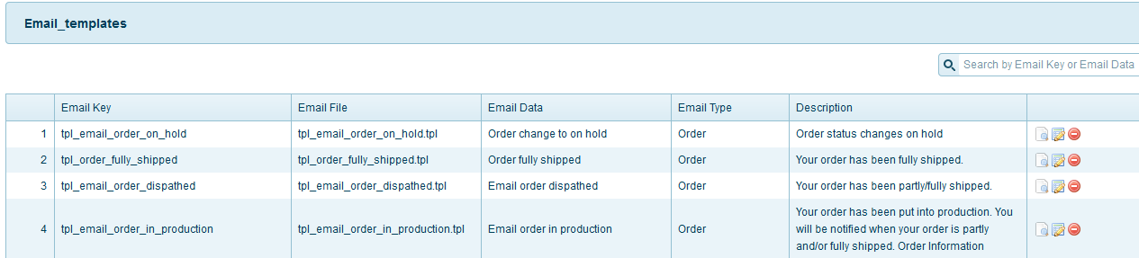

Please click the link **Add New** – menu top right from page **Email Templates**



Tab information: this part content all the information of email template and function will use for this email template. Right now system use email template only for order

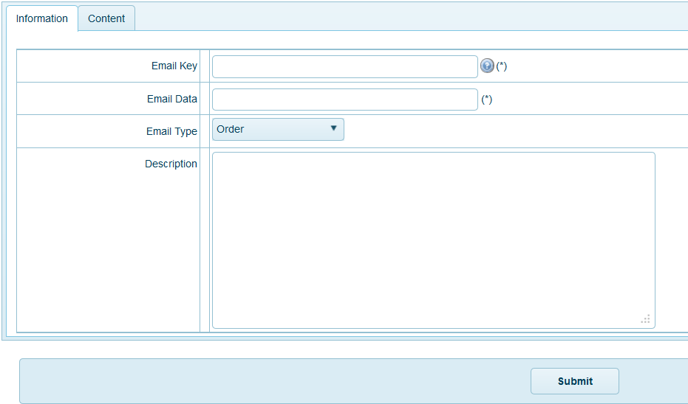

Tab Content will have all information send to customer

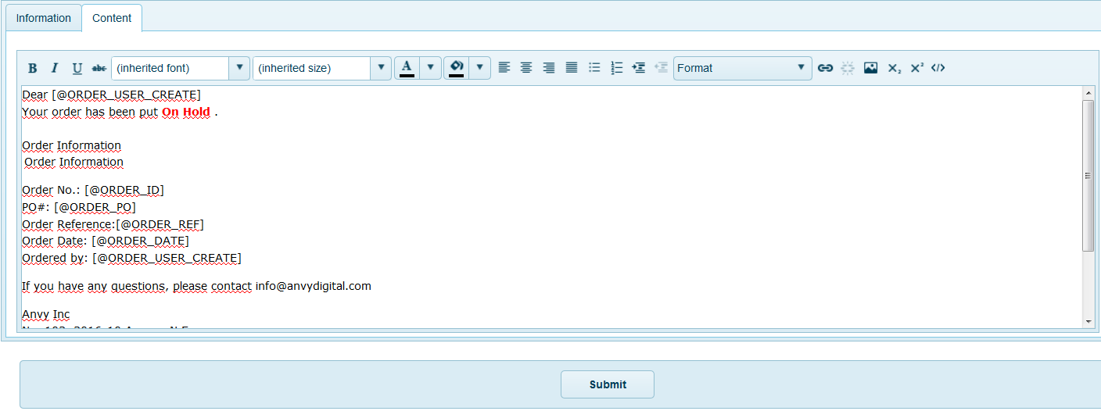

*Note: when create new email template, please follow these terms:

* [@ORDER_USER_CREATE]: system will send to person create order
* [@ORDER_PO]: system will replace this with order product order number
* [@ORDER_ID]: system will replace this with order id (create by system)
* [@ORDER_REF]: system will replace this with order product order ref
* [@ORDER_DATE]: system will replace this with date order create

### Export

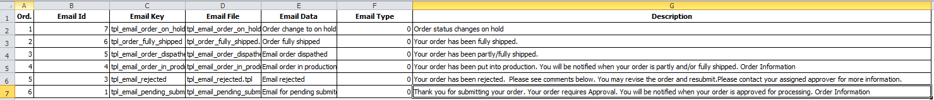

You want file contact Excel, please click icon Export

### Print

You want print file contact, please click icon print

### Content - page





**Search Email Templates:**  
You can search Email Templates use field name. Input Email Templates name you want to search here



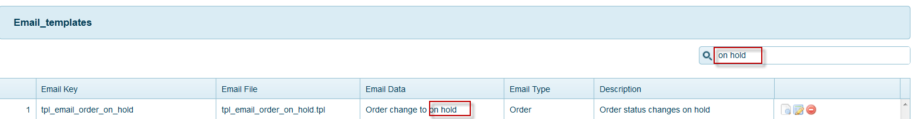



**Icon_view click ** View Email Templates information

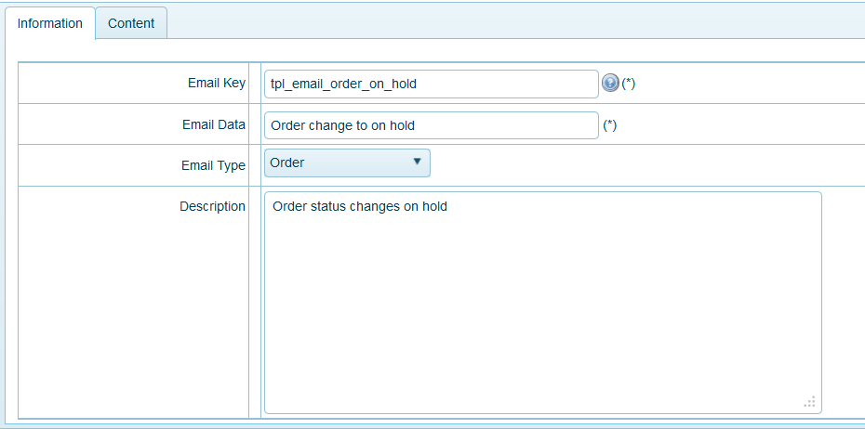

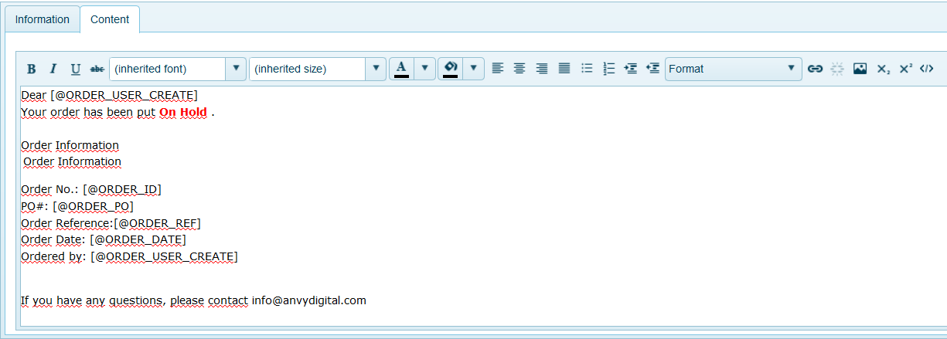

**Icon _edit click: ** if you want Edit email templates, please click icon_edit and then click ok, you will edit email templates selected.

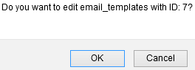

All field similar page Add new (you can view lates **Add New**)

**Icon _ delete: ** to delete email templates selected, please click ok to delete email templates

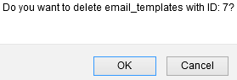

## **system – Global Configuration**

Description: Not avaliable

You can click from menu top System 🡪 Global configuration, or from menu left(when you clicked at least 1 menu from menu top) and then click menu you want.  
Here Global configuration:

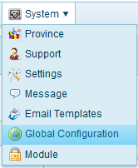

## **system – Module**

Description: This part of system is to add/remove items all menu and function on customer template and some function on admin page. So if you not sure what you are doing please do not edit anything.

You can click from menu top System 🡪 Module, or from menu left(when you clicked at least 1 menu from menu top) and then click menu you want, here Module:

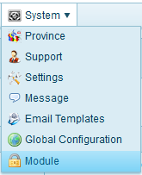 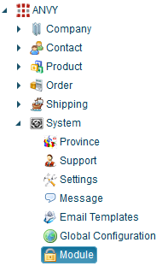

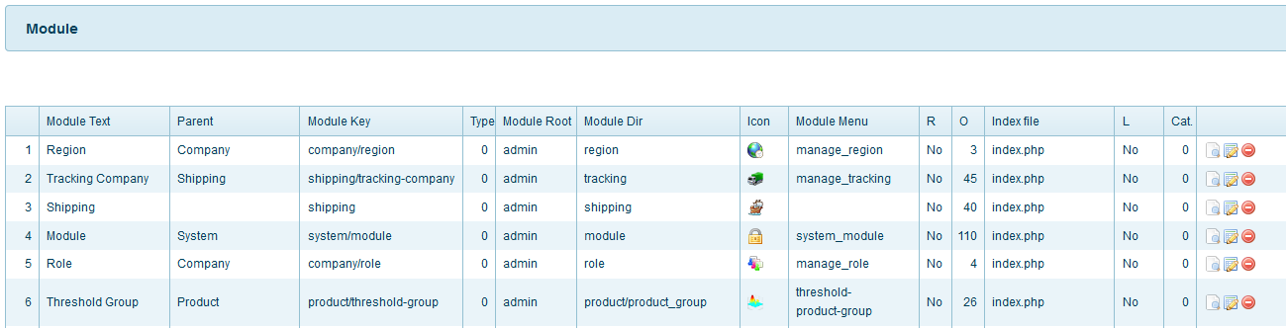

Function menu top right for page:



### Advanced

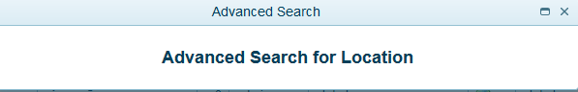

### Add new

Please click the link **Module** from menu **System  
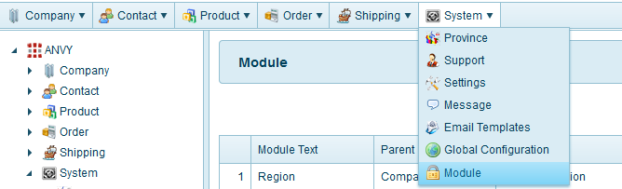**

You can saw this page **Module**

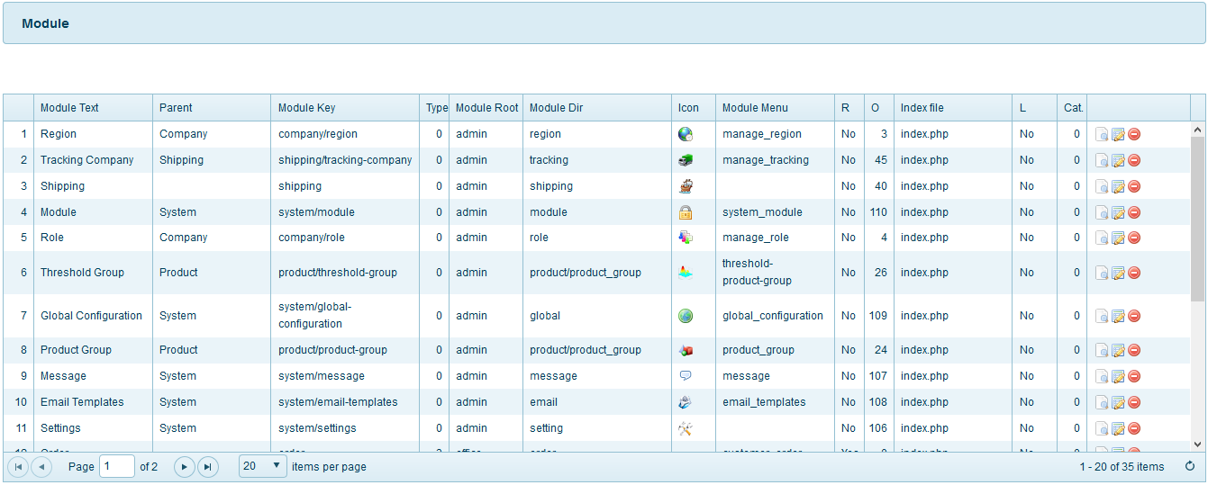

Please click the link **Add New** – menu top right from page **Module**



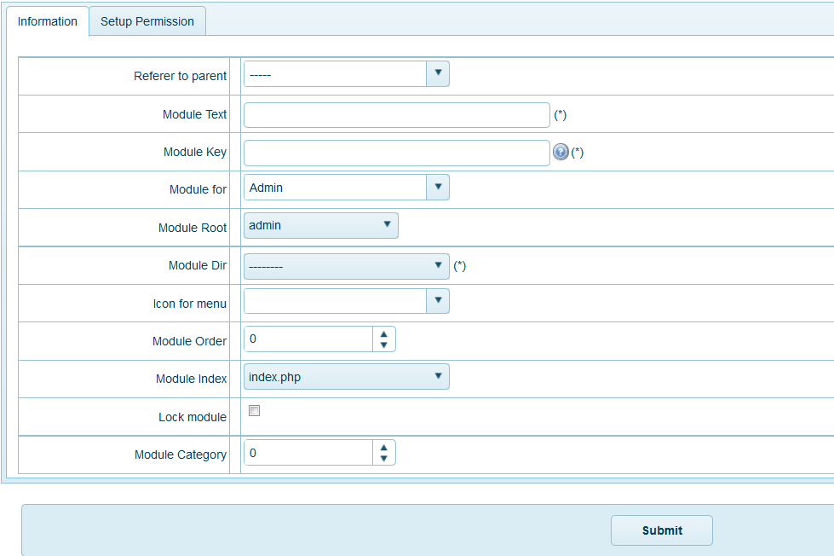

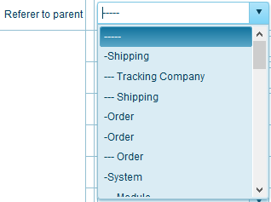

* **For example**: if you want to add new function for shipping then choose referrer to parent is shipping
* **Module for**: which type of admin will use this function. Admin system,   
  customer-admin or office admin  
  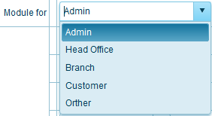
* **Module directory**: where you want to hold this function. With that example below we choose shipping.  
  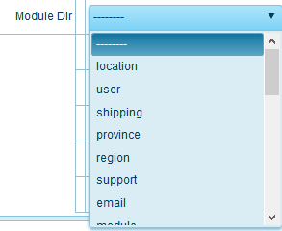
* Icon for this module:  
  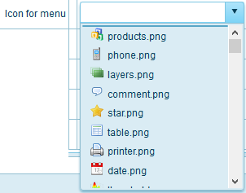
* Rule for this module (if exist)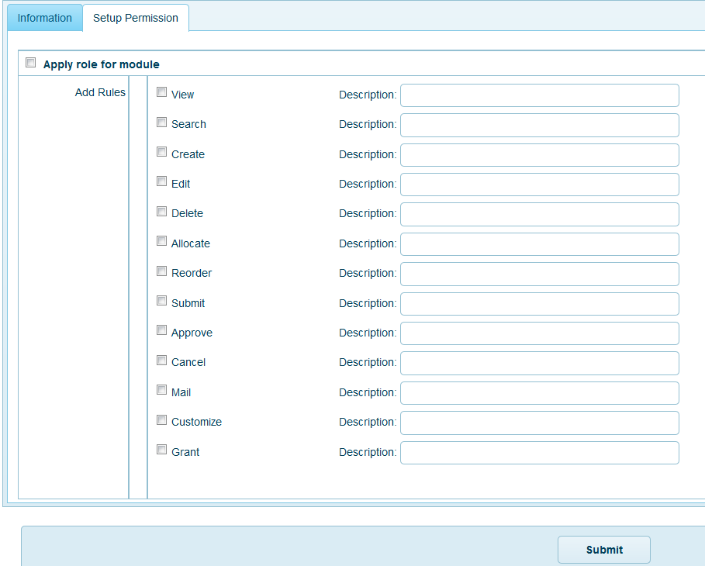

### Export





You want file contact Excel, please click icon Export

### Print

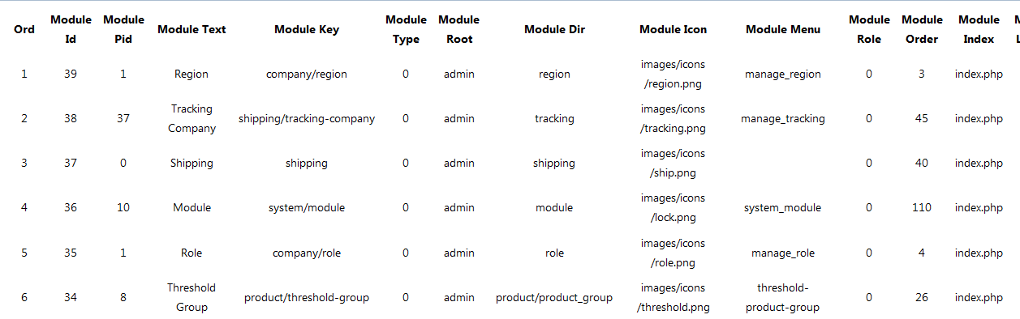

You want print file contact, please click icon print

### Content - page



**Icon_view click ** View Module

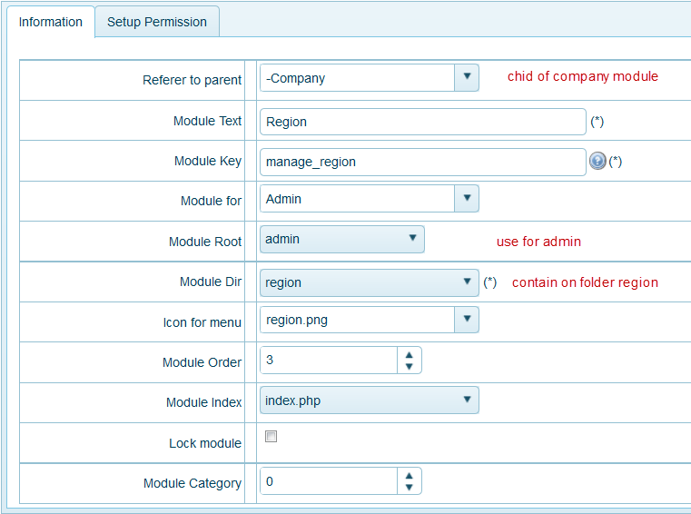

**Icon _edit click: ** if you want Edit Module, please click icon_edit and then click ok, you will edit Module selected.



All field similar page Add new (you can view lates **Add New**). After finishing editing module, click submit to save information

**Icon _ delete: ** to delete Module selected, please click ok to delete Module

